# CHECKOUT - INVENTORY PREPARED FOR

FLAT 16

199 OLD MARYLEBONE ROAD

LONDON

NW1 5QR

25TH APRIL 2020 / 24TH OCTOBER 2020

**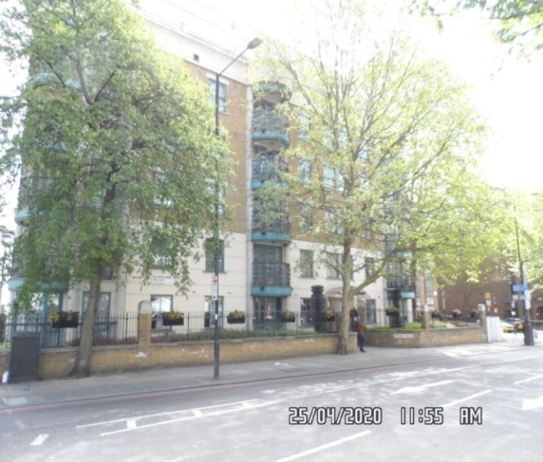**

|  |  |
| --- | --- |
| **CLIENT:** | First Port Lettings Services |
| **INSTRUCTED BY:** | Denise Shaw |
| **TENANTS:** | Lizzy Roberts & Fletcher Stucky |
| **WORK ORDER:** | 4604 |
| **REF:** | MBPS-002 / MBPS-002 |
| **INSPECTED BY:** | Gary Krienkie |
| **PROPERTY SIZE:** | 1 Reception/ 1 Bedroom/ 1 Bathroom/ 1 Store Room/ 1 Balcony - Furnished Flat |

'WINDY RIDGE' [99 COWLEY HILL, BOREHAMWOOD, HERTS, WD6 5NA](https://maps.google.com/?q=99+COWLEY+HILL,+BOREHAMWOOD,+HERTS,+WD6+5NA&entry=gmail&source=g),    TEL: 020 8 386 0950 - MOBILE: 077 67 647 647  
EMAIL: [info@inventorys.net](mailto:info@inventorys.net)<mailto:[info@inventorys.net](mailto:info@inventorys.net)>   [www.inventorys.net](http://www.inventorys.net/)  
Registered No: 4263261 VAT No: 822 9322 12

Safety Disclaimer

This inventory report is prepared as an ‘as seen snapshot’ of the property and its contents at the time of the designated inspection and is compiled as a fair and accurate record for the properties internal condition and contents. This does not form any part of a valuation or structural report.

This inventory is compiled on the basis that all items listed are in good order and clean. Any defects or soiling are noted where appropriate. Where inspections are carried out and the tenants’ belongings are in situ, it can be difficult for clerks to differentiate to that belonging to the landlord or tenant. Should the report contain inaccuracies the clerk (Independent Inventories (UK) Ltd) will not be held responsible.

The clerk preparing the inventory is not an expert in electrical appliances, antiques, furniture style, fabrics, flooring, etc. All descriptions within this report are for identification purposes only in order that each item can be compared to its condition at the commencement of the tenancy.

Lofts and Cellars are not included unless they are converted and safely accessible. Contents will therefore not be noted or checked at check in or checkout.

Plants and shrubs will not be itemised.

Belongings left by the landlord/agent in a locked room or outbuilding will not be inventoried and are the sole responsibility of the Landlord/agent. Items in garages/sheds such as garden equipment and tools will be inventoried, however tins of paint will not be itemised.

We do not undertake to move heavy items of furniture or access lofts, high-level cupboards, or any other inaccessible places. Contents which have been left in the above-mentioned areas, which have not been inventoried, are the sole responsibility on the landlord. We also do not undertake to open windows, but will confirm whether keys have been seen or not.

Any electrical appliances tested will be for power only and only where practicable. The clerks are not qualified electricians and will only confirm the visual condition of the electrical socket, wiring and or fitting as seen. Boilers, Heating Systems, Gas Fires, Water Supply and Radiators are not tested, and Independent Inventories (UK) Ltd will not take any responsibility for units left either on or off even if on automatic timers. Where smoke alarms and CO Detectors are tested this is for power only and should not be taken to mean that the alarms are in full working order. We only state their presence and cannot state the functioning of this equipment. No responsibility is taken for any damage or malfunction occurring during the testing of such alarms.

The relevant utility companies must check all meter readings, as we cannot be held responsible for any discrepancies. We are not held liable should meters not be located or inaccessible to read. For Health and Safety reasons we do not expect our clerks to access high level areas which involve using ladders/chairs.

The Fire & safety Regulations regarding furnishings, gas, electrical & similar services are ultimately the responsibility of the instructing principle. Where the inventory notes FFR label seen, this should not be interpreted to mean that the item complies with the furniture & furnishings (fire) (safety) (Amendments) 1993. It is a record that the item had a label as described or similar to that detailed in the Guide to the regulations as published by the Department of Trade & Industry, January 1997, (or subsequent edition), attached at the time the inventory was complied.

Blinds in the premises are visually checked. We are unable to verify that the blinds comply with child safety requirements of BS EN 131202009 + A1:2014 placed on the manufacturer, supplier and professional installation of internal window blinds

It is the responsibility of the landlord/managing agent/tenant to agree between themselves the accuracy of the report, and Independent Inventories (UK) Ltd should be notified within 7 days of receipt of the report of any discrepancies within the report.

GENERAL GUIDANCE NOTES

Independent Inventories do not have sight of tenancy agreements or other agreements made between the tenant, landlord and management company. As these are guidance notes only it is always advisable that the tenancy agreement is cross referenced. This report will indicate whether in our opinion the tenant is liable for the deterioration or whether it is considered fair wear & tear. Independent Inventories may suggest maintenance, cleaning or tenant’s liability at checkout, but the final responsibility of these suggestions will fall with the landlord or managing agent in respect of the original tenancy agreement. We do not suggest costs of any items, these should be sourced from the relevant contractors by the landlord or managing agent.

CLEANING

We recommend that a professional cleaning company is employed at the end of the tenancy, unless alternative arrangements have been agreed with the Landlord/Managing Agent. Receipts from professional cleaning and carpet cleaning companies must be present to the clerk at the checkout inspection.

If the standard of cleaning is not satisfactory most Landlords/Managing Agents will contract a cleaner and their charges will be charged to the tenant unless otherwise stated in the tenancy agreement.

DECORATION

It is accepted that during the course of the day to day living scuffs will appear on walls and woodwork. However, should the marks be found to be excessive charges will be made to you the tenant, unless otherwise stated in the tenancy agreement.

LIGHTING

If the lights are working at check in then it is normal, if lights are not working at checkout, for these to be the responsibility of the tenant to replace bulbs or to be charged accordingly, unless otherwise stated in the tenancy agreement.

GARDENS/PATIO

If the standard of the garden/patio is found to be untidy compared to the start of the tenancy the Landlord/Managing Agent are entitled to employ a contract gardener and the charge will be made to you the tenant, unless otherwise stated in the tenancy agreement.

MAINTENANCE ISSUES

We recommended should any maintenance issues arise you contact the Landlord/Managing Agent immediately so they can deal with the matter. Should we recommend items require maintenance once a property has been checked out, this is purely stating that an item will require fixing/attention, we are not advising as to whose responsibility this and your tenancy agreement will need to be checked.

CHANGES TO PROPERTY

We recommend that if you wish to make any changes to the décor or remove any of the Landlords belongings you contact the Landlord/Managing Agent for permission and have this confirmed in writing to ensure there are no discrepancies at the end of the tenancy.

TENANTS INFORMATION FOR CHECKING OUT OF PROPERTY

It is important at the checkout that:

1. All cleaning should be completed prior to the checkout appointment as per the tenancy agreement.
2. All personal items must be removed prior to the check out.
3. All items should be in the same location as per the inventory, any stored items should be unpacked and also returned to the same location.
4. If the Inventory clerk has to search for items or you still have belongings in the property to be removed this will result in additional charges being made to the tenant.
5. All beds should be left unmade with the linen folded. Bedding & towels should be cleaned & ironed where relevant.
6. All food items should be removed, freezers defrosted & doors left open & electricity turned off.
7. All light bulbs etc. should all be in working order as at check in.

The property should be left in a clean and tidy condition especially carpets, curtains, windows, upholstery appliances etc. We would suggest that you refer to your tenancy agreement in this matter.

If you are not ready to leave it may not be possible to carry out the checkout. In this case a return visit will be necessary resulting in a cancellation charge.

All keys to the property must be handed over at the time of checking out to the Inventory clerk or alternatively to the agents prior to the checkout taking place.

The Inventory Clerk acts as an independent and reasonable body and will avoid unnecessary criticism or derogatory comments when compiling or checking the Inventory.

At the termination of the tenancy the inventory will be checked and any obvious or significant discrepancies will be reported to the Managing Agent/Instructing Principal. This report will indicate whether in our opinion the tenant is liable for the deterioration or whether it is considered fair wear & tear. Normal fair wear and tear will be assessed on the lengthy of the tenancy and type occupancy.

INDEX

PAGE

|  |  |
| --- | --- |
| UTILITY READING | 1-2 |
|  |  |
| KEYS | 3 |
|  |  |
| GENERAL SUMMARY AT CHECKIN | 4 |
|  |  |
| INSTRUCTION MANUALS | 5 |
|  |  |
| ENTRANCE AND HALLWAY | 6-15 |
|  |  |
| STORE ROOM | 16-19 |
|  |  |
| BATHROOM | 20-29 |
|  |  |
| BEDROOM | 30-40 |
|  |  |
| RECEPTION | 41-53 |
|  |  |
| BALCONY | 54-55 |
|  |  |
| KITCHEN | 56-69 |
|  |  |
| DECLARATION AT CHECK IN | 70 |
|  |  |
| ADDITIONAL AMENDMENTS | 71 |
|  |  |
| SIGNED SCHEDULE OF CONDITION AT CHECK IN | 72-78 |

**UTILITY READINGS / KEY LIST& INSTRUCTION MANUALS**

|  |  |  |
| --- | --- | --- |
| **ELECTRIC** | **GAS** | **WATER** |
| METER NUMBER:  DO9A07747 | METER NUMBER:  N/A | METER NUMBER:  N/A |
| READING:  18674  27387  Supplied by the agent | READING:  N/A | READING:  N/A |
| LOCATION:  Basement cupboard | LOCATION:  N/A | LOCATION:  N/A |
| SUPPLIER: | SUPPLIER: | SUPPLIER: |

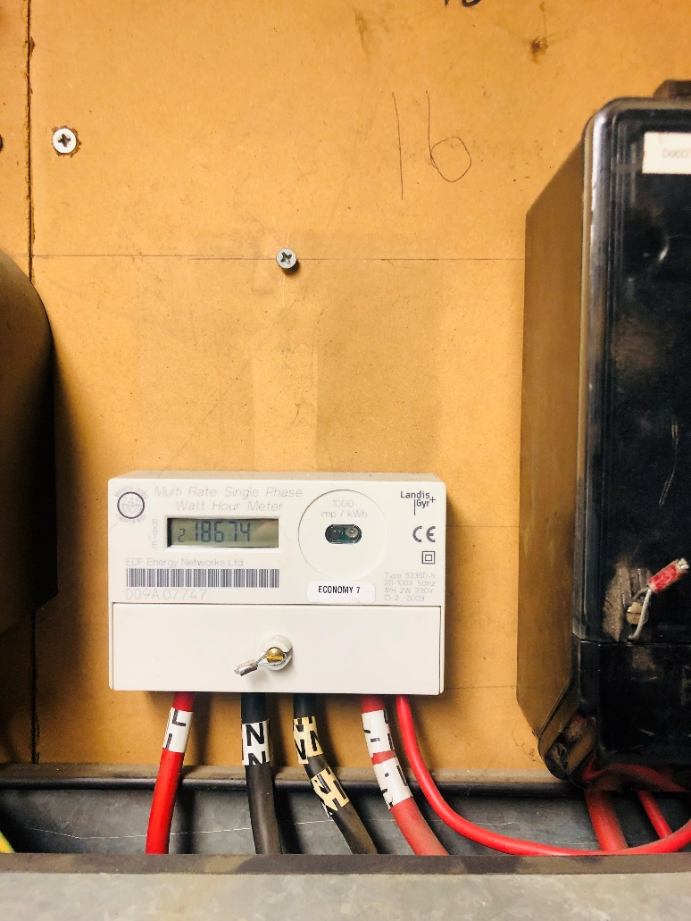

|  |  |  |
| --- | --- | --- |
| **ELECTRIC** | **GAS** | **WATER** |
| METER NUMBER:  DO9A07747 | METER NUMBER:  Bot applicable | METER NUMBER:  N/A |
| READING: | READING:  N/A | READING:  N/A |
| LOCATION:  Basement cupboard  Door double locked – unable to access | LOCATION:  N/A | LOCATION:  N/A |
| SUPPLIER: | SUPPLIER:  N/A | SUPPLIER: |

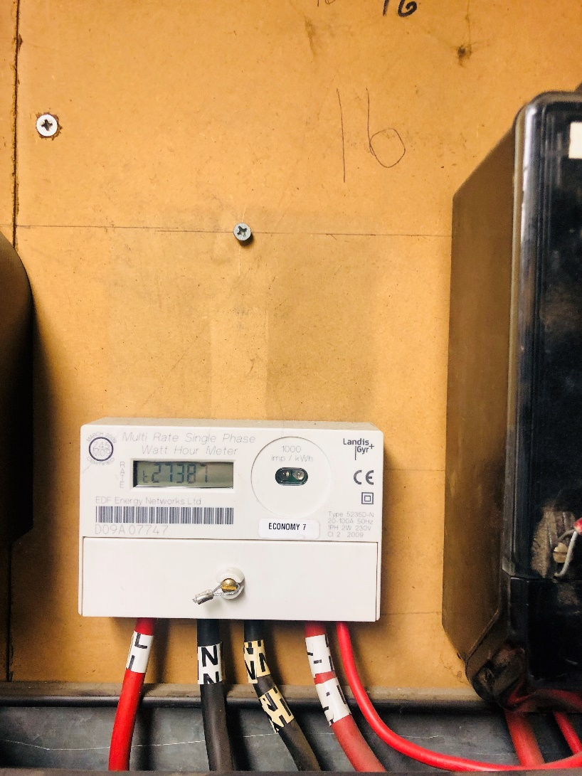

|  |
| --- |
| **LOCATION OF:** |

|  |  |  |
| --- | --- | --- |
| **STOP COCK** | Store room | |
| **FUSE BOARD** | Store room | |
| **ALARM PANEL**  **This has not been tested** | None | MAKE: |

|  |
| --- |
| **FIRE SAFETY** |

|  |  |
| --- | --- |
| **SMOKE ALARM** | Battery powered  Power light on  Tested with Canned smoke and working order  Location: Reception room |
| **CARBON MONOXIDE ALARM** | N/a |

|  |  |  |
| --- | --- | --- |
| **KEYS AT CHECKIN** | **KEYS AT CHECKOUT** | |
| **KEY TYPE / SERIAL NUMBER / QTY** | **KEY TYPE / SERIAL NUMBER / QTY** |
| 5 x Silver Yale | 6 x Silver Yale |
| 1 x Blue fob | 2 x Blue fob |
| 1 x Mailbox | 1 x Mailbox |
| 2 x Multi locks | 2 x Multi locks |
|  |  |
|  |  |
| **KEYS RECEIVED BY: Tenant**  E:\Preetha\FILES\II\APRIL - 2020\27TH APRIL\FLAT 16, 199 OLD MARYLEBONE - MAKE\Pictures\SAM_2416.JPG | **KEYS RETURNED TO:Agent NAIL SALIH Foxtons – Blandiford St will** | |

|  |
| --- |
| **GENERAL SUMMARY** |

|  |  |  |
| --- | --- | --- |
| **ITEM** | **CHECKIN NOTES** | **CHECKOUT NOTES** |

|  |  |  |  |
| --- | --- | --- | --- |
| **GENERAL CONDITION** | | Professionally cleaned for start of tenancy | Domestically cleaned for the end of tenancy |
| **ODOUR** | | N/A | N/A |
| **DECORATIVE ORDER / WOODWORK** | | Good order  Defects as noted  Woodwork scuffed/ chipped | Defects as noted  Woodwork scuffed/ chipped |
| **FLOORING** | | Good order  Defects as noted  Vacuumed for start of tenancy | Defects as noted  Vacuumed for end of tenancy |
| **CURTAINS / BLINDS** | | Requires further cleaning  Defects as noted | Defects as noted |
| **BLIND REGULATIONS** | | N/A |  |
| **UPHOLSTERY** | | Defects as noted | Vacuumed in situ for end of tenancy  Defects as noted |
| **FFR LABELS** | FFR Labels seen | |  |
| **LINEN** | None provided | | Not seen |
| **LIGHTS** | All working order | | Bulbs not working |
| **KITCHEN / APPLIANCES** | All appliances power tested  Fridge/ freezer left shut power on  Requires further cleaning | | All appliances power tested  Fridge/ freezer left shut power on |
| **BATHROOMS/**  **WC** | Clean  Water outlets tested and working  Requires further cleaning | | Clean  Mildew to areas as noted |
| **WINDOWS** | Fitments complete  Clean to interior  Requires further cleaning | | Fitments complete  Clean to interior |
| **GARDEN /**  **TERRACE** | Seasonal order | | Seasonal order |

|  |  |
| --- | --- |
| **MANUALS SUPPLIED AT**  **CHECKIN** | **MANUALS RETURNED AT**  **CHECKOUT** |
| **APPLIANCE / MAKE** | **APPLIANCE/MAKE** |
| None provided | None provided |
|  |  |
|  |  |
|  |  |
|  |  |

 \*N.B – Heavy items will not be moved or inspected behind/under, for health & safety reasons. We will not be held liable should any damages/stains/marks be found during the tenancy in these areas. Should the occupant find any of the above they should, inform the landlord/agent immediately and if/where possible take photographic evidence and pass to the relevant parties.

 This camera symbol throughout the Inventory check in/out indicates where a photo has been taken. Photos can be found at the back of each room in the report with the relevant headings

**ENTRANCE HALLWAY**

|  |  |  |  |
| --- | --- | --- | --- |
| **Door** | Exterior Door Frame  Frame light wooden varnished  1 x draught excluder seen to inside edges of frame  Light wooden varnished threshold upon entrance | 1. ~~1 or 2 x~~ Light marks consistent with use in places mid to low-level 2. Threshold general marks consistent with use |  |
|  | Exterior Door  Door light wooden varnished  2 x panels  Stainless steel “16”  Stainless steel spyhole  Stainless steel knob handle with matching surround  Silver aluminium Yale lock with matching surround  1 x stainless steel secondary lock with matching surround  1 x fire chain attached to door | 1. Some light scratching around Yale lock areas 2. Mid and high-level some light shading seen on edges 3. Some light scuffing seen mid to low-level 4. Knob handle ~~slightly~~ loose |  |

**ENTRANCE HALLWAY**

|  |  |  |  |
| --- | --- | --- | --- |
| **Door contd..,** | Interior Door Frame  Frame painted magnolia | 1. ~~1 or 2 x~~ Light hairline cracks along edges |  |
|  | Interior Door  Door light wooden varnished  2 x panels  Stainless steel spyhole with matching cover  Stainless steel lock box  Stainless steel twist lock with matching surround  1 x reverse bolt from knob handle | 1. Lock box loose 2. Some scratching seen to door at mid-level 3. Some scuffing in places mid to low-level, otherwise intact |  |

**ENTRANCE HALLWAY**

|  |  |  |  |
| --- | --- | --- | --- |
| **Walls** | Painted magnolia | 1. Light marks consistent with use in places 2. Light scuffing and rub marks in places most notably left-hand side 3. Some light finger soil marks visible in places around bathroom light switch and to left-hand side wall 4. Some patchy paintwork seen right-hand side at high-level 5. Rear facing wall above mirror and ceiling in this area some light orange staining appears to be light water staining and stress crack |  |
| **Ceiling** | Painted white | 1. 1 or 2 x light scuff marks seen 2. Some light chipping around recessed light |  |

**ENTRANCE HALLWAY**

|  |  |  |  |
| --- | --- | --- | --- |
| **Lights** | 3 x recessed spotlights with white metal surround | 1. All tested and working for power |  |
| **Woodwork** | Skirting painted magnolia | 1. ~~1 or 2 x~~ Light rub marks in places 2. Not inspected underneath any furniture 3. Some light hairline cracking seen to top surface |  |
| **Switches and sockets** | Silver and white plastic | 1. All appears to be intact and good order 2. Light paint mark seen around edges |  |

**ENTRANCE HALLWAY**

|  |  |  |  |  |
| --- | --- | --- | --- | --- |
| **Flooring** | Light wooden laminate flooring | 1. Scattered scratches and tiny heel indent marks seen in places scattered throughout 2. Vacuum for the ~~start~~ end of tenancy 3. ~~Some light debris present~~ 4. Flooring creaky in places |  |  |
| **Radiator** | Electric radiator  White wooden laminate cover with matching lattice | 1. Unable to fully inspect due to cover 2. Some light scuffing seen to top surface |  |  |
| **Smoke alarm** | 1 x ceiling mounted smoke alarm  Expiration date: July 2021 | 1. Green light showing 2. Slightly loose from ceiling, maintenance required |  |  |

**ENTRANCE HALLWAY**

|  |  |  |  |  |
| --- | --- | --- | --- | --- |
| **Entry phone** | 1 x Electra entry phone white plastic with LED display | 1. Tested and working for power |  |  |
| **Shoe tidy** | White wooden laminate  4 x drawers  Black metal knob handles to exterior | 1. ~~Knob handles slightly loose~~ 2. Some light scuffing seen to both interior and exterior |  |  |
| **Picture frames** | 7 x white wooden laminate frames with clear plastic protectors  2 x white metal with clear plastic protectors | 1. All showing light marks consistent with use |  |  |
| **Mirror** | 1 x white wooden laminate framed bevelled edge mirror | 1. Clean to top surface |  |  |

**ENTRANCE HALLWAY**

|  |  |  |  |  |
| --- | --- | --- | --- | --- |
| **Coat hanger** | Black metal with 8 x double hooks | 1. Appears to be intact and good order |  |  |

Entrance and hallway Entrance and hallway

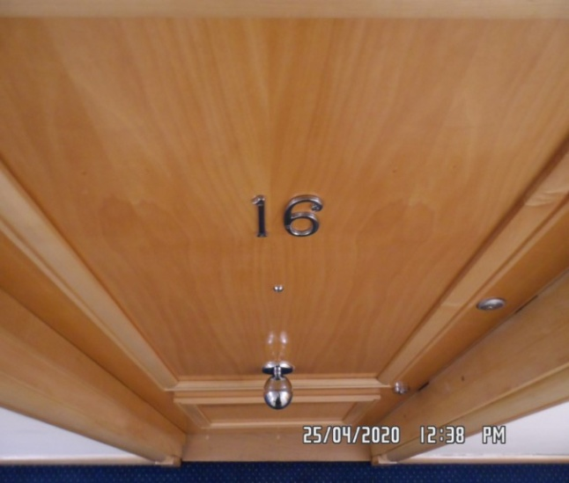 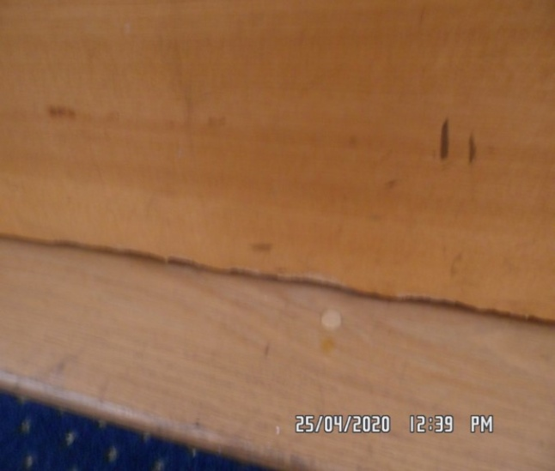

Entrance and hallway Entrance and hallway

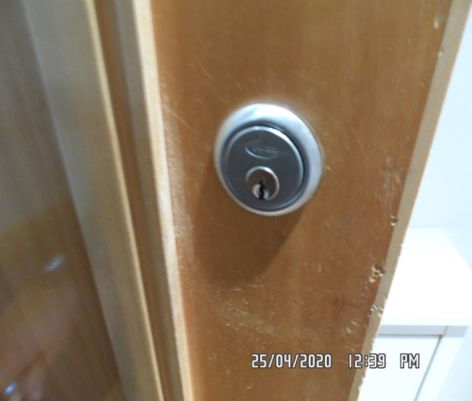 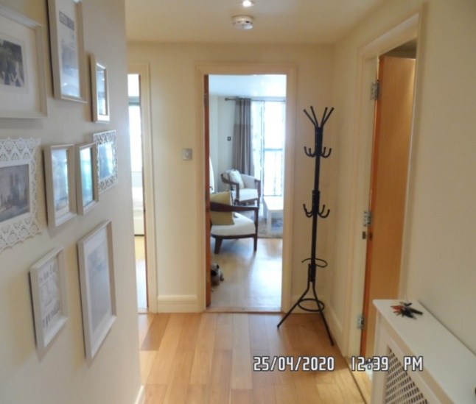

Entrance and hallway Entrance and hallway

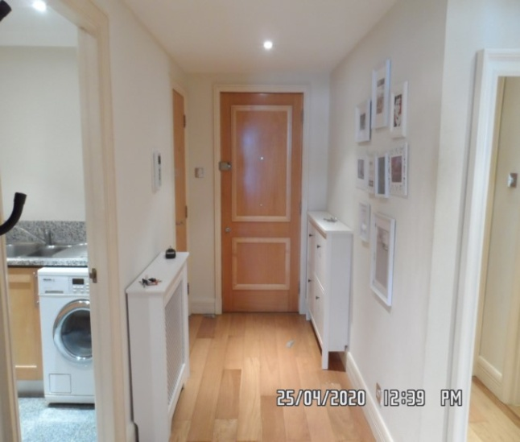 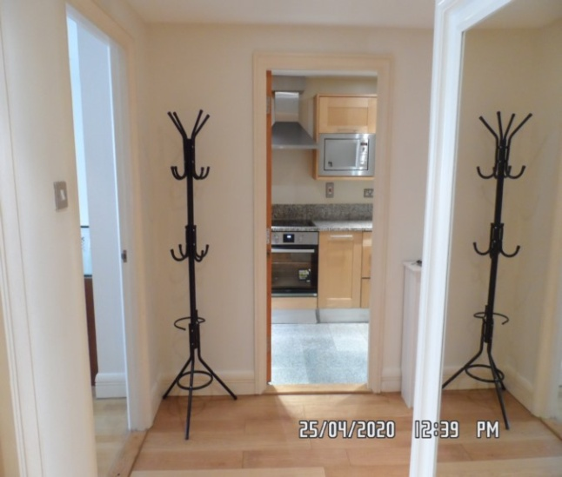

Entrance and hallway Entrance and hallway

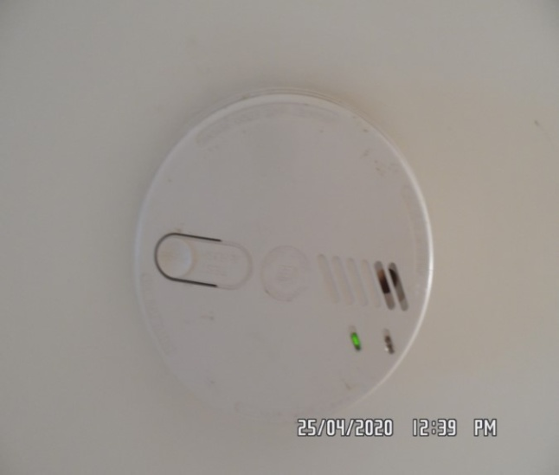 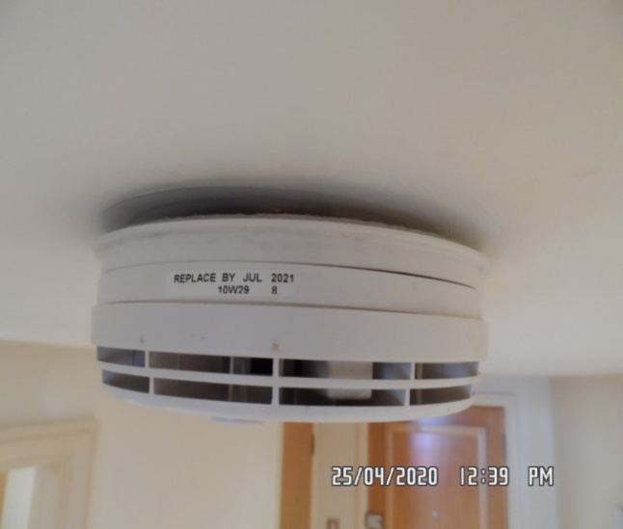

Entrance and hallway Entrance and hallway

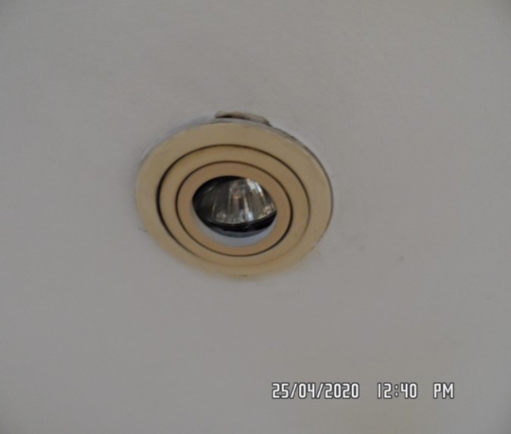 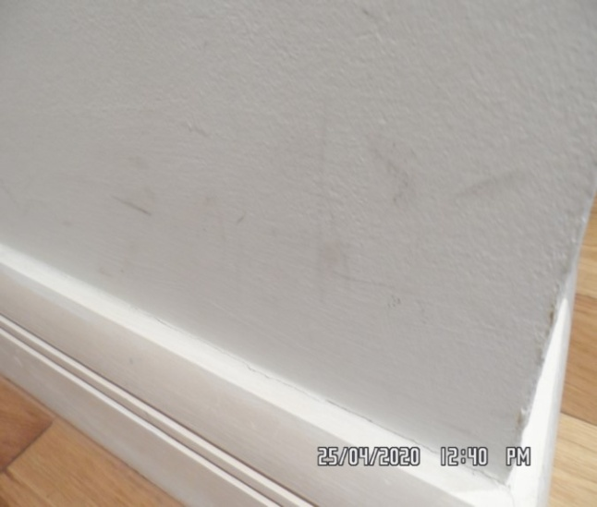

Entrance and hallway Entrance and hallway

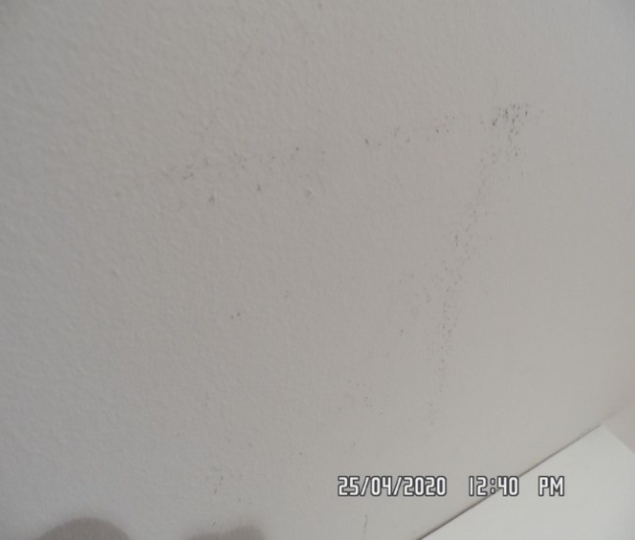 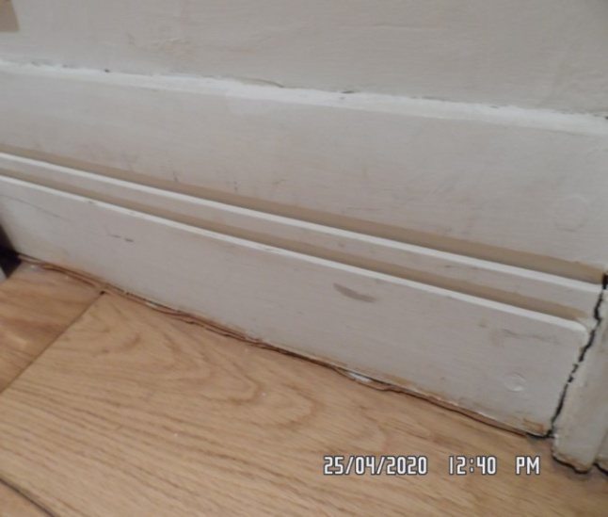

Entrance and hallway Entrance and hallway

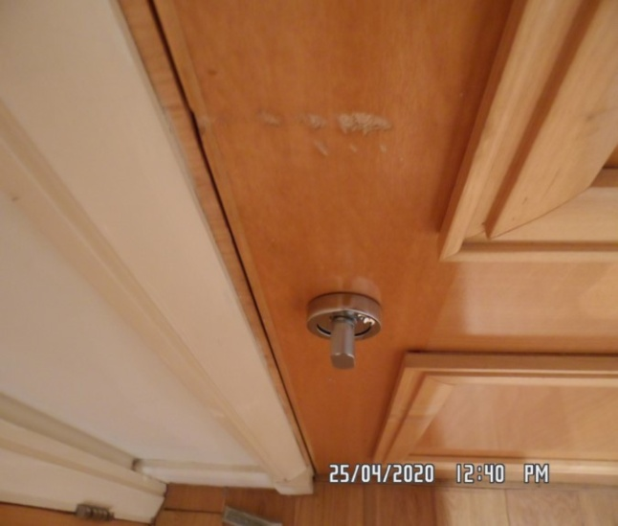 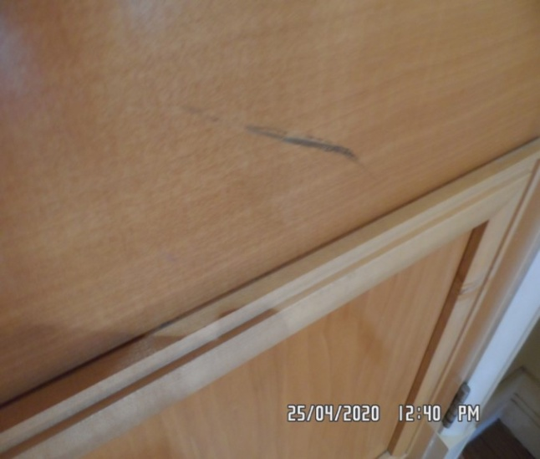

Entrance and hallway Entrance and hallway

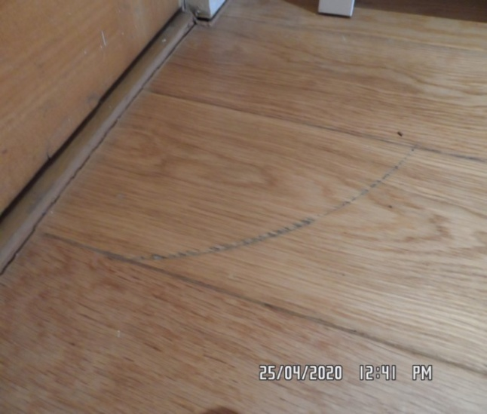 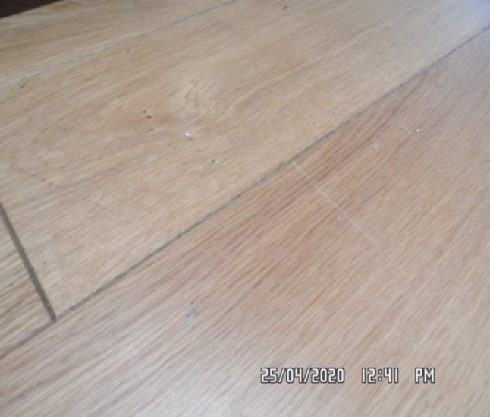

Entrance and hallway Entrance and hallway

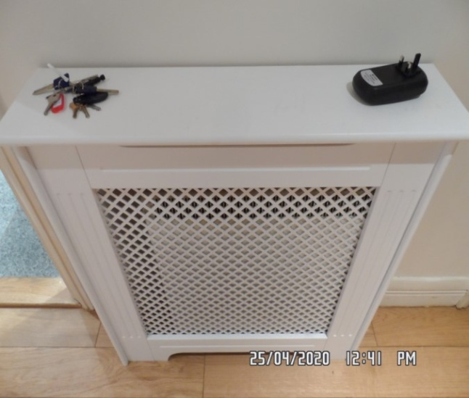 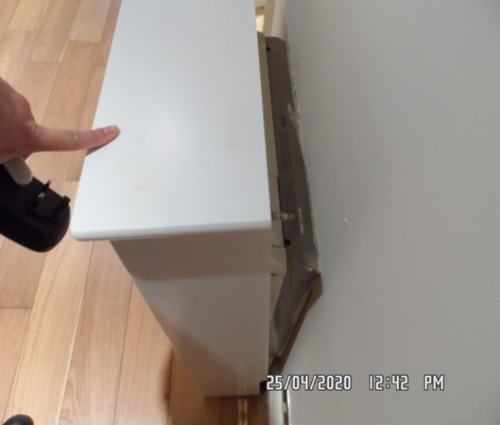

**STORE ROOM** - Poor lighting

|  |  |  |  |
| --- | --- | --- | --- |
| **Door** | Exterior Door Frame  Frame painted magnolia  Light wooden varnished threshold upon entrance | 1. Threshold general marks consistent with use, slightly loose |  |
|  | Exterior Door  Door light wooden laminate  Silver plastic lever handle with matching surround  1 x silver plastic hook | 1. Some patchy paintwork around edges of frame 2. Hook to exterior broken 3. ~~1 or 2 x~~ Light scuffs seen low-level exterior |  |
|  | Interior Door Frame  Frame painted magnolia | 1. Unable to fully inspect   Not inspected base on CI comments |  |
|  | Interior Door  Door light wooden laminate | 1. Some light shading seen around edges 2. Some scuffing seen mid to low-level |  |

**STORE ROOM**

|  |  |  |  |
| --- | --- | --- | --- |
| **Walls** | Painted magnolia | 1. ~~Appears to be freshly painted~~ Scattered rubs / scuffs to walls |  |
| **Ceiling** | Painted white | 1. ~~Freshly painted~~ 2. Old defects underneath |  |
| **Woodwork** | Skirting painted white | 1. Scattered rubs / scuffs to wood where visible |  |
| **Switches and sockets** | White plastic | 1. All appears to be intact |  |
| **Flooring** | Unfinished | 1. Unable to fully inspect due to lack of lighting (see picture for description) |  |

**STORE ROOM**

|  |  |  |  |
| --- | --- | --- | --- |
| **Fuse boxes** | 2 x off-white with clear grey flaps | 1. Both appears to be intact |  |
| **Hot water heating tank** | 1 x hot water heating tank with further white metal tank above this with associated copper pipe work | 1. All appears to be intact |  |
| **Ironing board** | 1 x black frame ironing board  Blue and white cover | 1. General marks consistent with use |  |
| **Clothes airer** | 1 x white metal clothes airer | 1. Appears to be intact 2. Not fully inspected |  |
| **Vacuum cleaner** | 1 x black and white vacuum cleaner  Associated cable work and pipe work | 1. Brand name not seen |  |

**STORE ROOM**

|  |  |  |  |
| --- | --- | --- | --- |
| **Mop and bucket** | 1 x grey mop and bucket | 1. In use |  |
| **Mop** | 1 x blue and silver mop | 1. Appears to be in use |  |
| **Carpet** | 1 x rolled up carpet | 1. Not inspected 2. Appears to be Persian carpet |  |

Store room Store room

**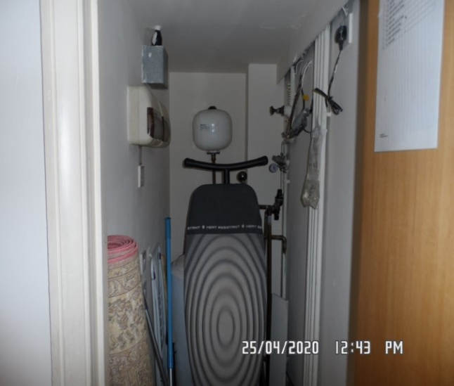 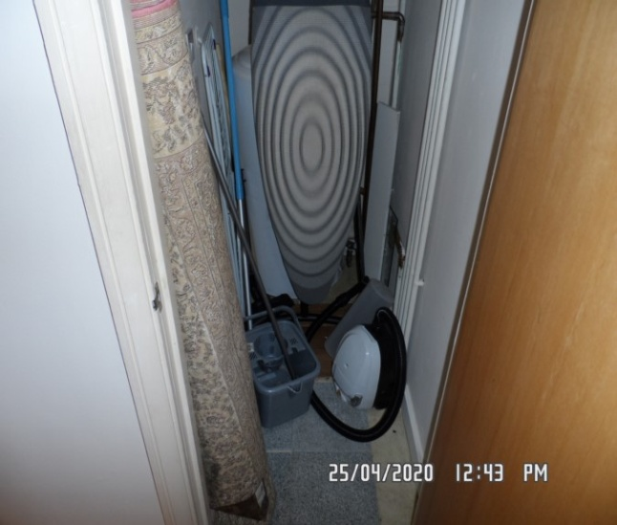**

**BATHROOM**

|  |  |  |  |
| --- | --- | --- | --- |
| **Door** | Exterior Door Frame  Frame painted magnolia  Light wooden varnished threshold upon entrance | 1. Patchy paintwork seen around edges 2. ~~1 or 2 x~~ Light scuff marks seen left-hand side mid to low-level 3. Threshold general marks consistent with use |  |
|  | Exterior Door  Door light wooden laminate  Stainless steel lever handle with matching surround  Reverse of twist lock with matching surround | 1. Handle loose 2. 1 or 2 x chips seen to top edge and bottom edge at an angle |  |
|  | Interior Door Frame  Frame painted magnolia | 1. Appears to be intact |  |

**BATHROOM**

|  |  |  |  |
| --- | --- | --- | --- |
| **Door contd..,** | Interior Door  Door light wooden laminate  Stainless steel lever handle with matching surround  Stainless steel twist lock with matching surround  1 x plastic hook seen  1 x fire chain attached to door | 1. Handle loose 2. Some light scuffing seen at high and low-level very minor |  |
| **Walls** | Part painted magnolia  Part light brown ceramic tiled with white grout  1 x white metal ventilator to front facing wall | 1. Rear facing wall with 2 x brushed stainless steel hooks and 2 x adhesive pad residue marks seen 2. Some white ingrained drip marks forward of front facing wall mid-level 3. Elsewhere light discolouration seen to tile sections 4. Some light shading in places 5. Left-hand side wall some light scuffing mid to low-level 6. Some light grey shading seen around edges of ventilator |  |

**BATHROOM**

|  |  |  |  |
| --- | --- | --- | --- |
| **Ceiling** | Painted white | 1. ~~Some cobwebs build up~~ 2. 1 or 2 x light scuff marks seen 3. Some chipping seen around recessed light |  |
| **Lights** | 3 x recessed spotlights with white metal surround | 1. All tested and working 2. Recessed light above bath area has come loose from surround, maintenance required |  |
| **Switches and sockets** | Silver and white plastic shaver only socket | 1. Intact |  |
| **Flooring** | Light brown tile effect lino | 1. Some ingrained staining right-hand side of toilet 2. Some further shading and marks consistent with use in places 3. Pink stain forward of back walls near bath. Not recorded but can seen in CI photo |  |

**BATHROOM**

|  |  |  |  |
| --- | --- | --- | --- |
| **Radiator** | White painted ladder style radiator | 1. Attachment loose in places, further maintenance required 2. Currently showing power 3. Odd scuff to metal |  |
| **Sink** | White ceramic basin  Stainless steel integrated mixer tap  Cut-out for overflow  Stainless steel surround  Stainless steel popup plug  Sink sat in white stone worktop  1 x access panel for toilet | 1. Clean to interior 2. 1 x hairline crack right-hand side of sink 3. Some orange ingrained staining seen 4. 1 x small chip right hand side interior base of sink 5. Light scratches to steel 6. Rusting under lever 7. Stain right hand side worktop behind WC |  |
| **Toilet** | White ceramic toilet  White plastic toilet seat and lid  Stainless steel flush attached to rear wall | 1. Clean to interior 2. Flush appears to be intact 3. Possibly light chemical drip stain under lid |  |

**BATHROOM**

|  |  |  |  |
| --- | --- | --- | --- |
| **Bath** | White enamel bath  Stainless steel surround  Stainless steel popup plug control  Stainless steel integrated mixer tap  Stainless steel shower hose  Silver plastic showerhead  Silver plastic showerhead attachment  White wooden laminate bath panel | 1. Bath forward of shower guard 1 x chip seen 2. Some light mould residue along the edges of sealant 3. Interior bath some dull spots and ingrained staining- unsure whether this requires further cleaning or maintenance (see picture for description) 4. Showerhead clean |  |
| **Shower guard** | Silver aluminium hinges  Single panelled glass  Clear plastic seal | 1. Sealant to bottom now lighter stain ~~discoloured / orange~~ 2. Further cleaning required |  |
| **Medicine cabinet** | 2 x mirror panels to exterior  White wooden laminate to interior  6 x glass shelves  2 x white wooden laminate base shelves | 1. Light marks consistent with use 2. Exterior mirror panels some silvering seen around edges |  |

**BATHROOM**

|  |  |  |  |
| --- | --- | --- | --- |
| **Waste basket** | ~~1 x white plastic waste basket~~ Tenant replaced with aqua plastic waste basket |  |  |
| **Set of scales** | 1 x Salter set of scales | 1. Appears to be intact 2. Not tested |  |

Bathroom Bathroom

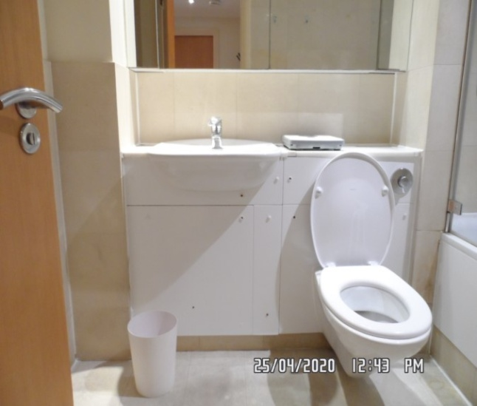 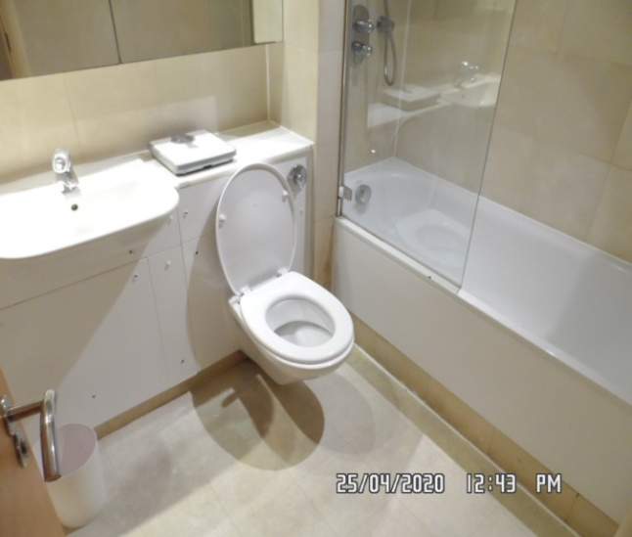

Basin Bathroom

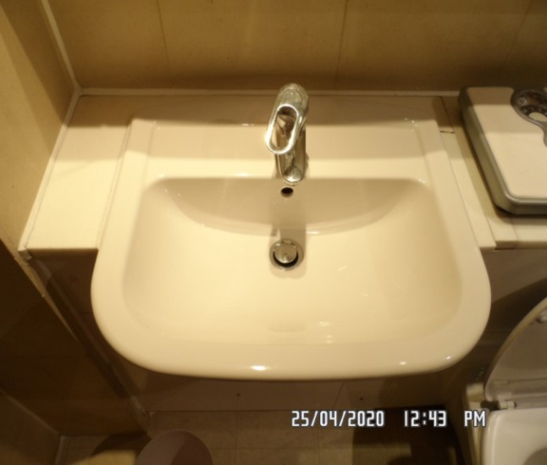 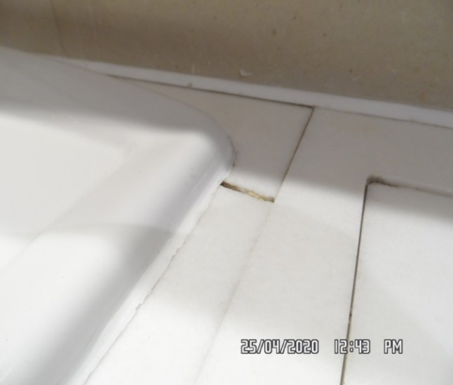

Bathroom Toilet

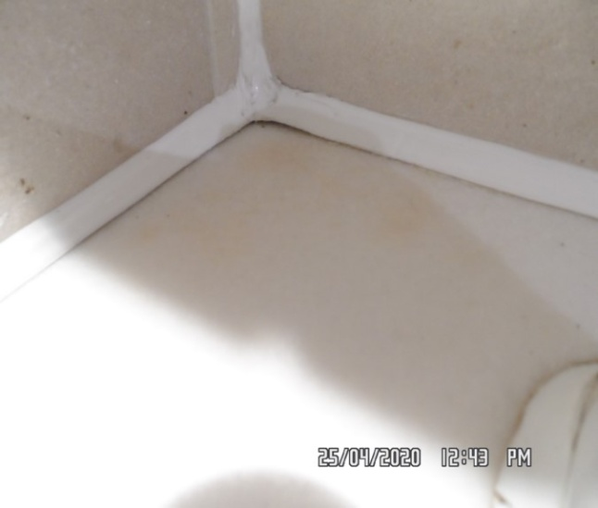 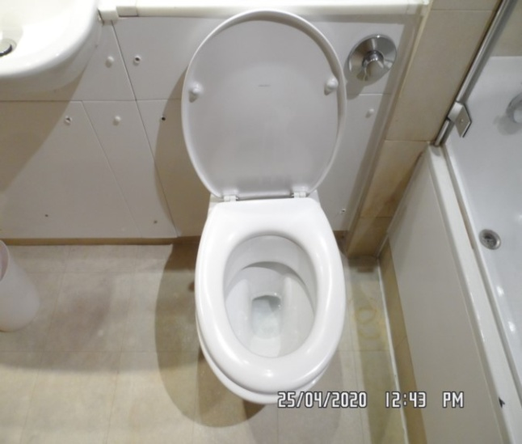

Bathroom Bathroom

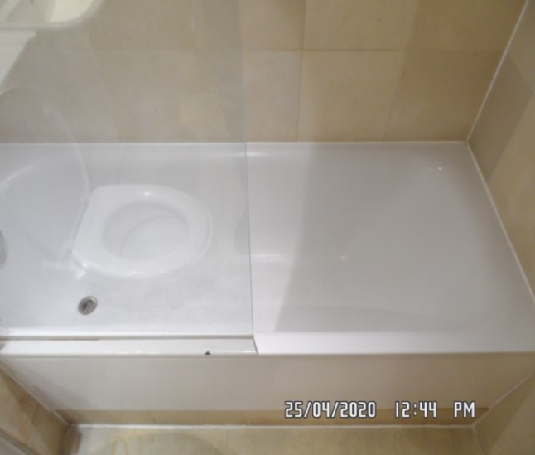 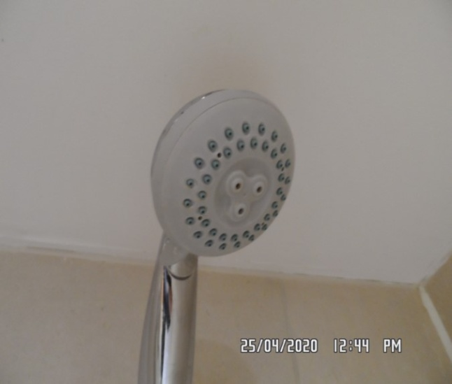

Bathroom Bathroom

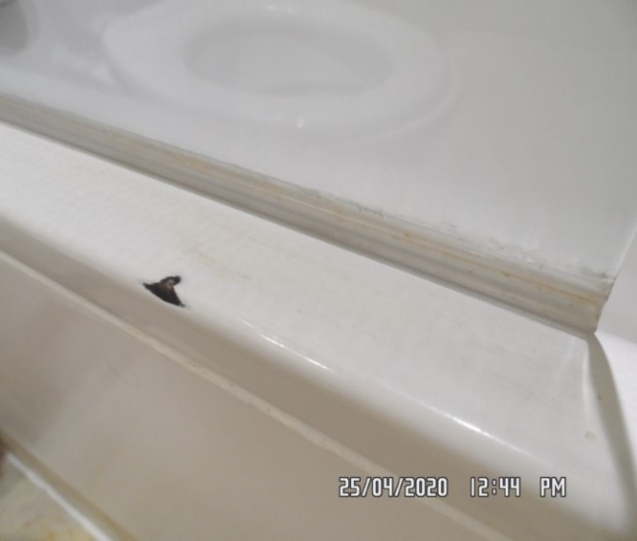 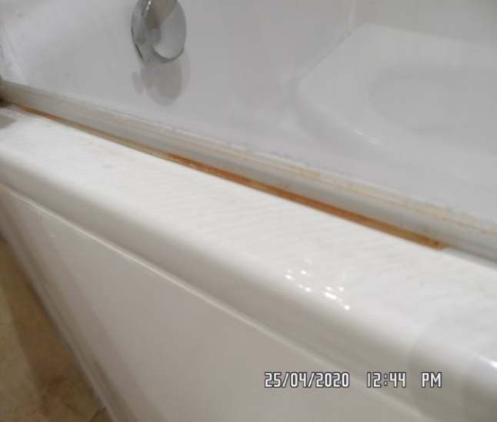

Bathroom Bathroom

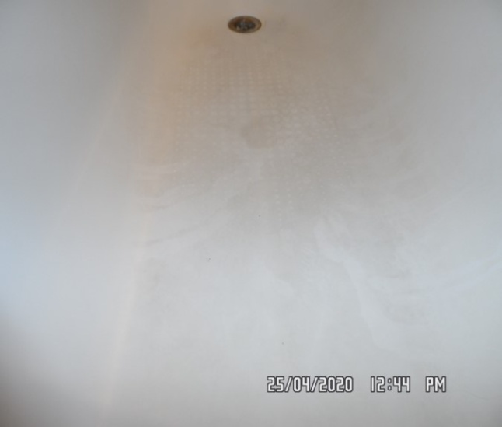 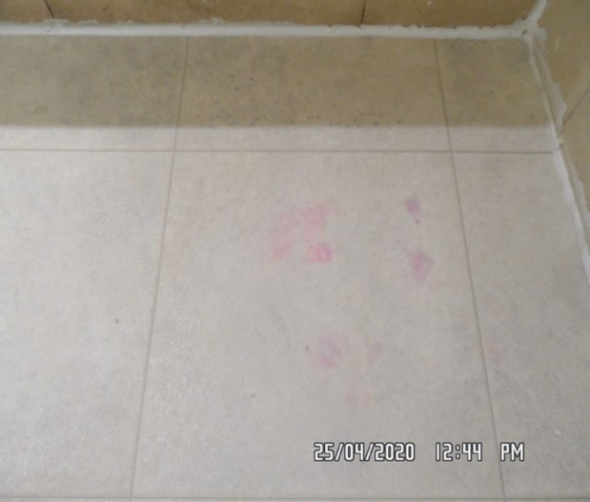

Bathroom Bathroom

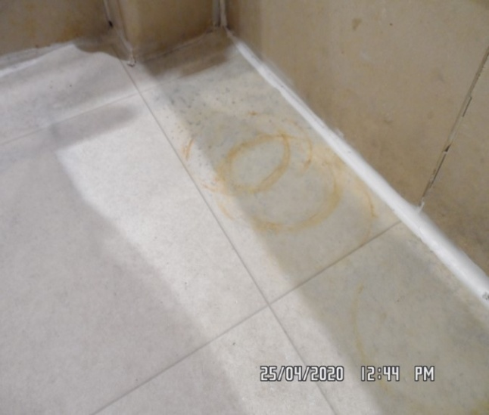 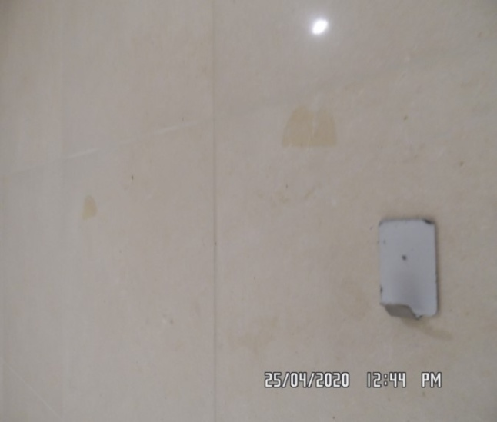

Bathroom Bathroom

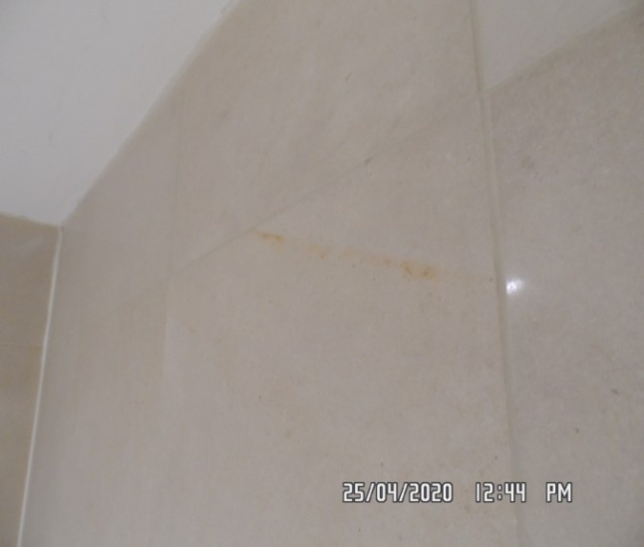 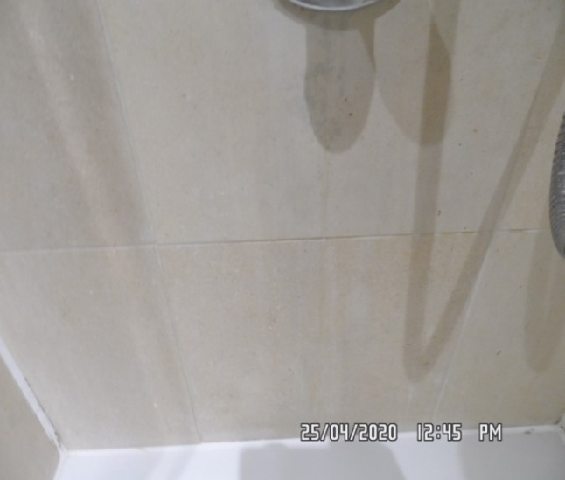

Bathroom Bathroom

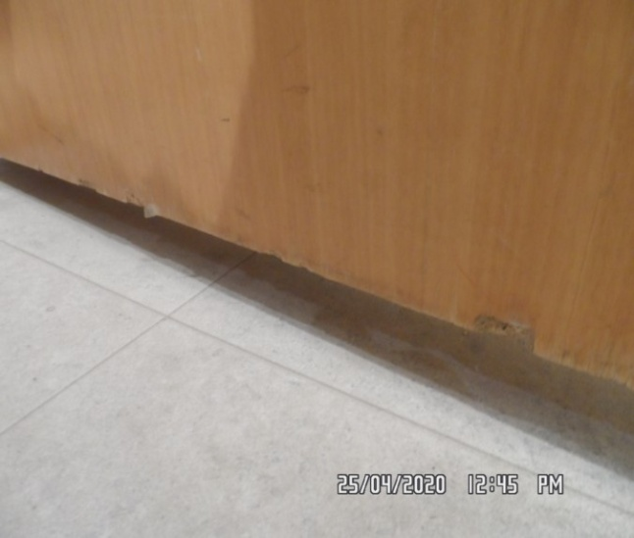 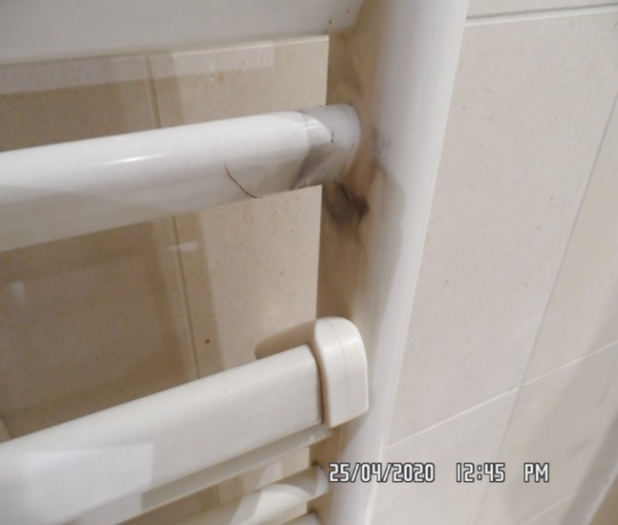

Bathroom Bathroom

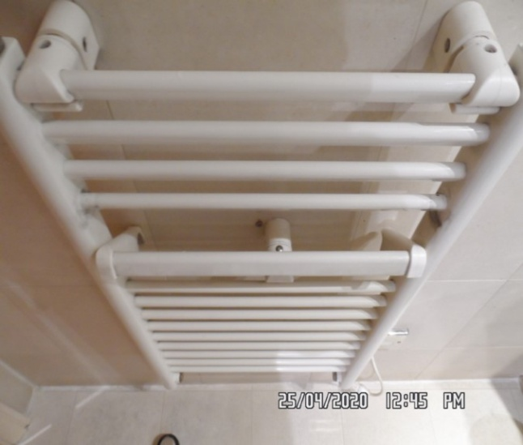 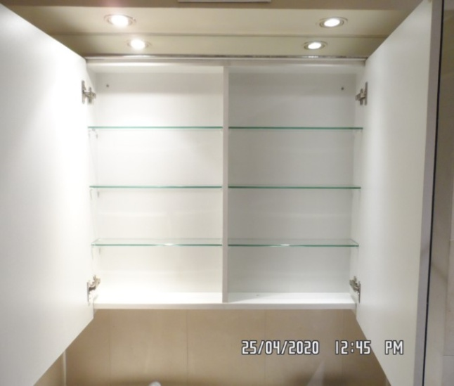

Bathroom Bathroom

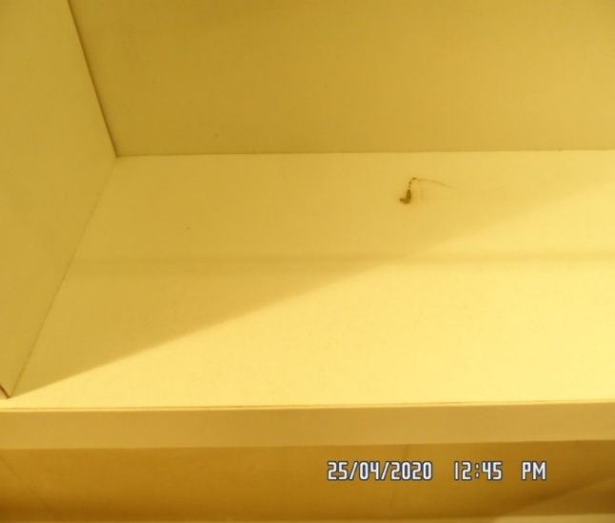 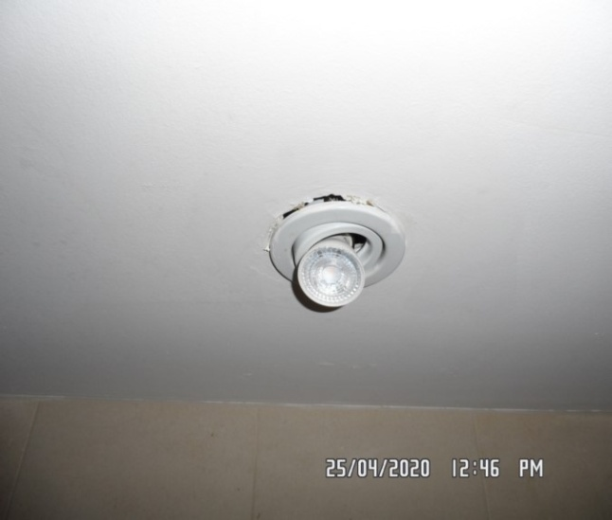

**BEDROOM**

|  |  |  |  |
| --- | --- | --- | --- |
| **Door** | Exterior Door Frame  Frame painted magnolia  Light wooden varnished threshold upon entrance | 1. Patchy paintwork and light grey shading seen around edges 2. 1 or 2 x chips seen mid to low-level 3. Threshold general marks consistent with use 4. 2 x hairline cracks seen to top surface of threshold |  |
|  | Exterior Door  Light wooden laminate door  Stainless steel lever handle with matching surround | 1. Some light chipping seen to bottom edges at an angle 2. Some light scuffing in places mid to low-level 3. Handle slightly loose |  |
|  | Interior Door Frame  Frame painted magnolia |  |  |

**BEDROOM**

|  |  |  |  |
| --- | --- | --- | --- |
| **Contd..,** | Interior Door  Light wooden laminate door  Stainless steel lever handle with matching surround  1 x fire chain attached to door | 1. Appears to be intact and good order      1. Handle slightly loose |  |
| **Walls** | Painted missing | 1. 1 or 2 x Llight scuff marks and rub marks in places mid to low-level 2. Left-hand side wall 1 x nail seen to wall at high-level some light finger soil marks around light switches 3. Not inspected behind any furniture 4. Left and right-hand side of blind some old defects seen 5. Along edges of window area some light mould residue seen to walls and sealant (see picture for description) 6. Right hand side wall – 3 pin holes upper level 7. Right hand side wall – door handle conflicts with wall 8. Right hand side – 3 x residue sticker upper level near chest of drawers |  |

**BEDROOM**

|  |  |  |  |
| --- | --- | --- | --- |
| **Ceiling** | Painted white | 1. 1 or 2 x light scuff marks seen in places, otherwise intact 2. Some light chipping around recessed lights to ceiling |  |
| **Lights** | 5 x recessed spotlights with white metal surround | 1. 1 or 2 x appears to be slightly loose from ceiling 2. 1 x not working |  |
| **Woodwork** | Skirting painted magnolia | 1. Skirting where visible ~~1 or 2 x~~ light rub marks and light chipping to corner edges at an angle 2. Not inspected behind any furniture |  |
| **Switches and sockets** | Silver and white plastic | 1. Plug socket appears to be slightly loose from wall, maintenance required |  |

**BEDROOM**

|  |  |  |  |
| --- | --- | --- | --- |
| **Windows** | White metal encasement and frame double-glazed  1 x fixed panel high-level  1 x opening panel beneath  Silver aluminium twist lock  1 x Yale lock  2 x pull handles  Silver aluminium glazing  Sill painted magnolia | 1. ~~Slightly smudge to interior, final wipe required~~ 2. Exterior soiled 3. Grey shading and light mould residue seen along edges of sealant 4. Sill some light grey shading and patchy paintwork seen to top surface 5. Sealant around edges cracking seen |  |
| **Curtains** | Light grey fabric blind | 1. No chain break or chain tidy attached to this unit |  |
| **Flooring and beading** | Light wooden laminate | 1. Beading unable to fully inspect behind any furniture 2. Where visible beading appears to be complete 3. Flooring vacuum for the ~~start~~ end of tenancy 4. Some light scratches and drag marks in places – all very minor |  |

**BEDROOM**

|  |  |  |  |
| --- | --- | --- | --- |
| **Radiator** | White wooden laminate cover with matching lattice | 1. Radiator unable to fully inspect due to radiator cover 2. 1 or 2 x light scuff marks seen to top surface of unit |  |
| **Built-in wardrobe** | White wooden laminate to both interior and exterior doors  Brushed stainless steel handle to exterior  Interior walls light wooden laminate  Unit from left to right:  Unit 1:  Double opening door unit  1 x hat shelf  1 x stainless steel hanging rail  1 x base shelf  2 x plastic hooks seen to exterior door  Unit 2:  Single opening unit  1 x hat shelf  1 x shelf  2 x stainless steel hanging rails  1 x base shelf  Exterior door 1 x plastic hook attached | 1. Unit 1: 1 or 2 x light scuff marks and scratches seen to doors to exterior 2. ~~Interior base shelf unable to fully inspect due to contents (see photo)~~ no contents on shelf 3. Unit 2: Light marks consistent with use in places 4. Interior hinge ~~struck slightly, door not shutting flush~~ 5. Hinge now fitted at an angle – top of door is not in line with unit 1 door |  |

**BEDROOM**

|  |  |  |  |
| --- | --- | --- | --- |
| **Bed frame** | 1 x white wooden laminate bed frame, double size  Matching headboard  2 x drawers to underside | 1. 1 or 2 x chips seen around edges in places 2. Odd scuff to drawers |  |
| **Mattress** | White with brown stripes | 1. Some ripping seen to mattress to labelled side 2. Not inspected to unlabelled side 3. ~~Some light~~ Grey shading and 1 or 2 x stain marks in places . Mattress in use |  |
| **Bedside table** | White wooden laminate with single drawer  Brushed stainless steel handle | 1. Some light marks consistent with use to both interior and exterior |  |
| **Chest of drawers** | 1 x white wooden laminate with black metal knob handles  5 x drawers | 1. Light marks consistent with use to interior 2. Crack to wood to side of unit upper level |  |

**BEDROOM**

|  |  |  |  |
| --- | --- | --- | --- |
| **Dressing table** | White wooden laminate with matching mirror  Single drawer white wooden laminate with matching knob handle | 1. 1 or 2 x light marks consistent with use 2. Some chipping seen around edges in places 3. ~~Light dust build up in places~~ |  |
| **Stool** | 1 x white fabric seater cushion | 1. General staining to top surface 2. Light debris in places 3. Further cleaning required |  |
| **Table lamp 1** | Brass base and stem, white shade | 1. Further cleaning required 2. Not tested |  |
| **Table lamp 2** | Glass base and white shade | 1. Not tested for power |  |

Bedroom Bedroom

**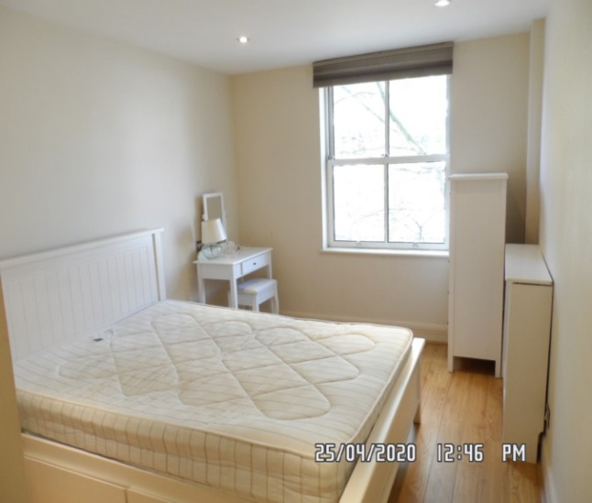 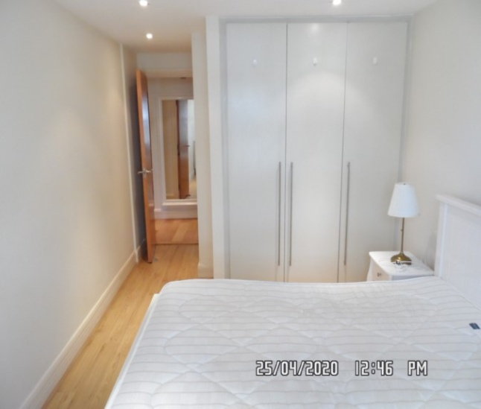**

Bedroom Bedroom

**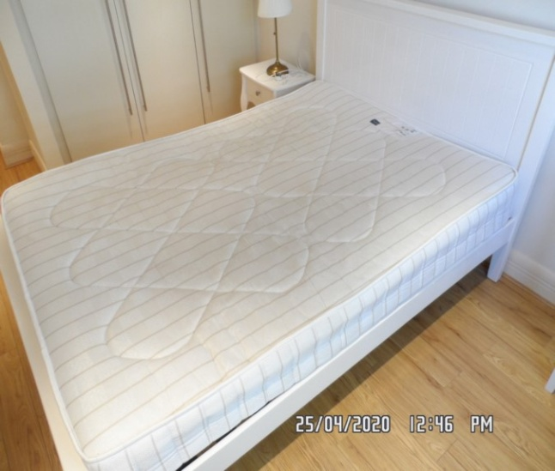 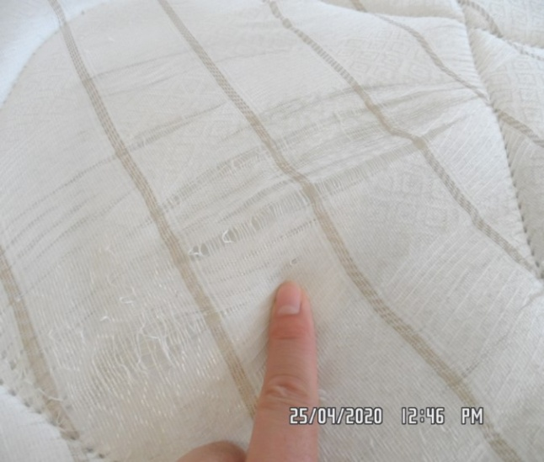**

Bedroom Bedroom

**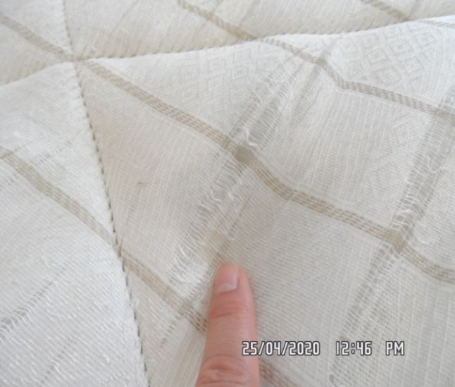 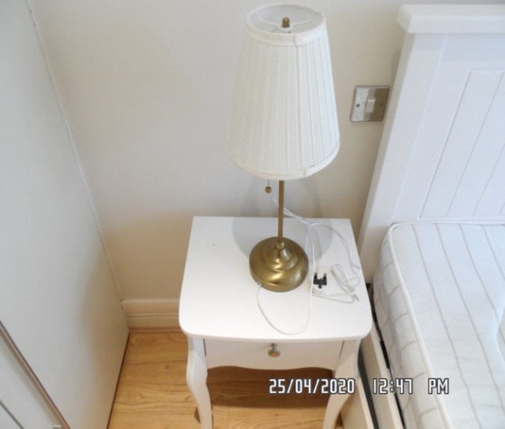**

Bedroom Bedroom

**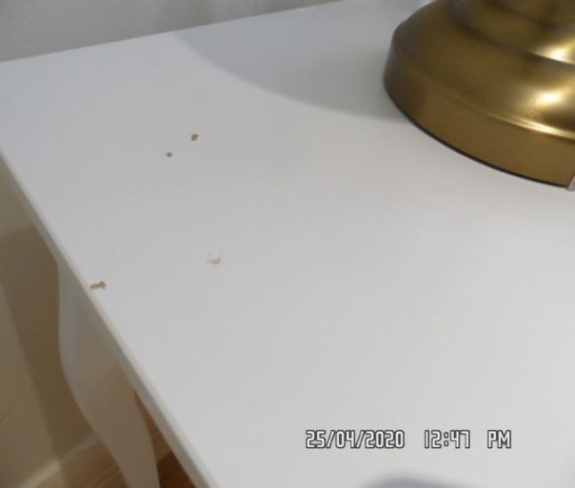 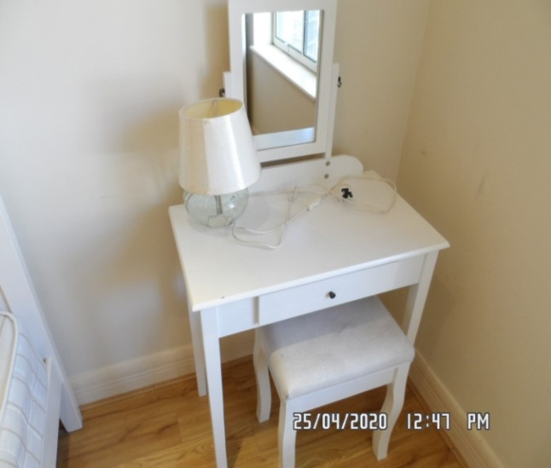**

Bedroom Bedroom

**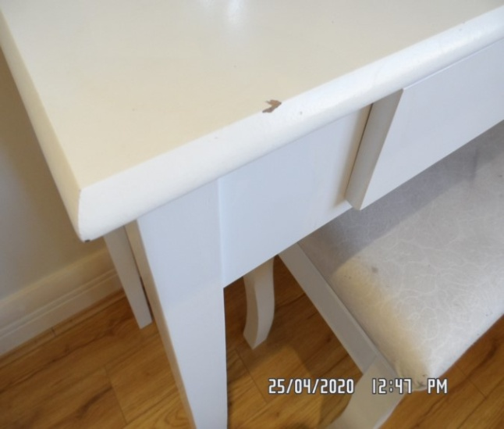 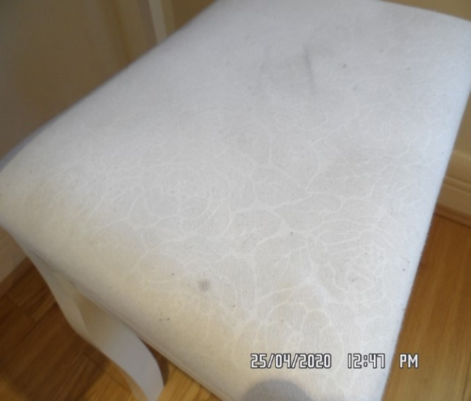**

Bedroom Bedroom

**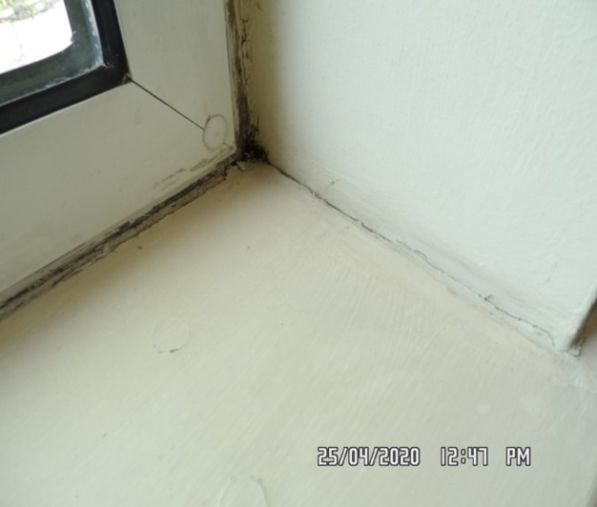 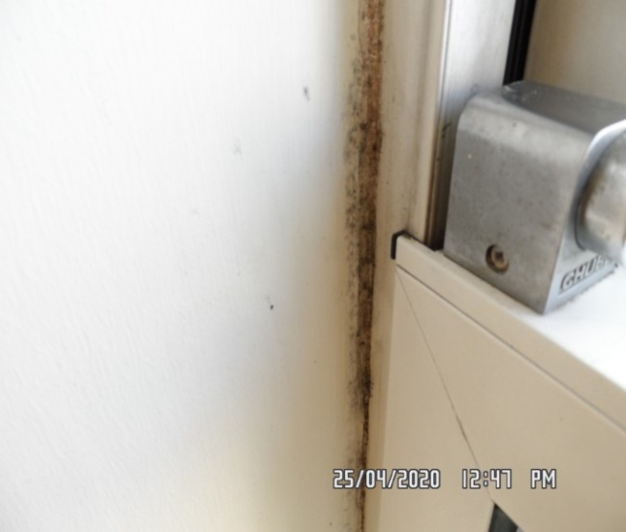**

Bedroom Bedroom

**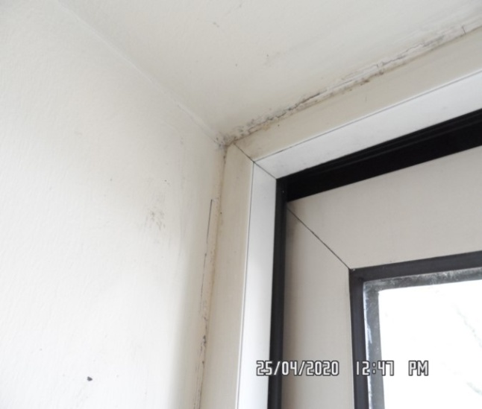 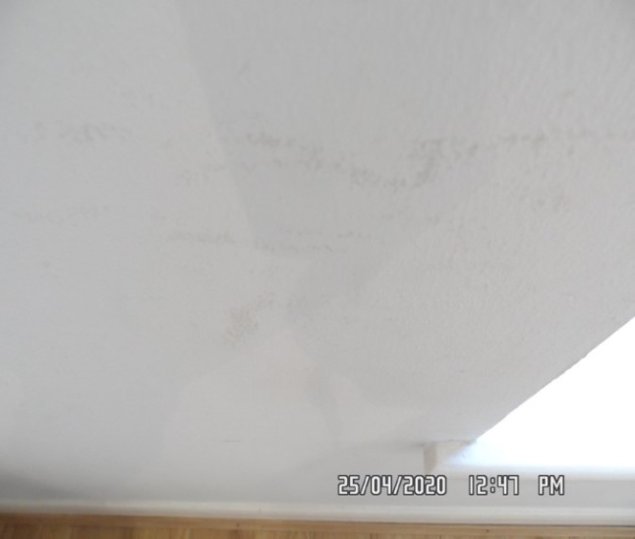**

Bedroom Bedroom

**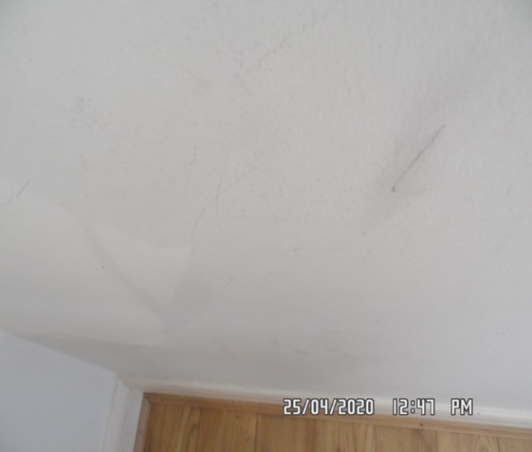 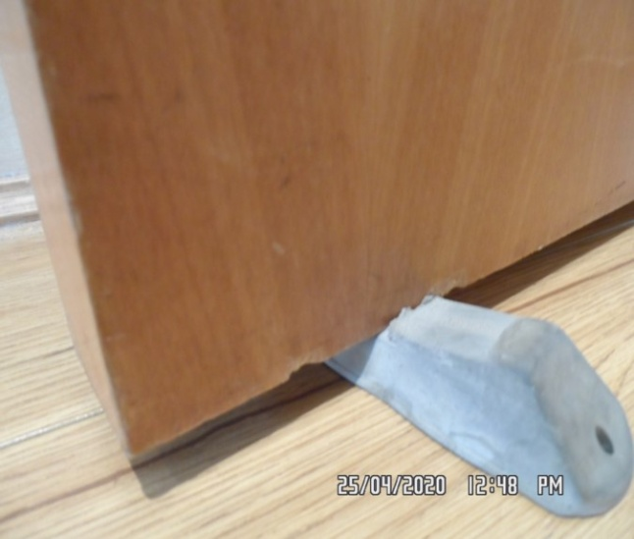**

Bedroom Bedroom

**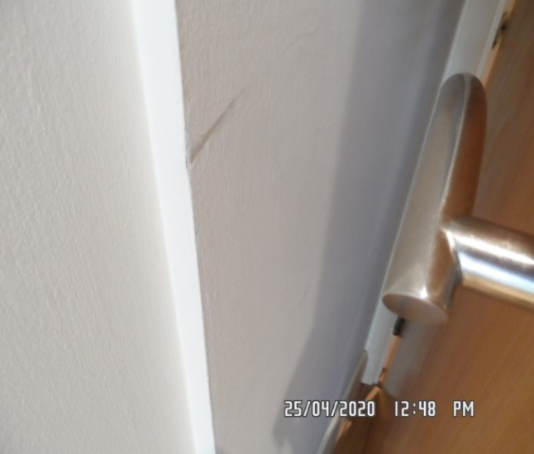 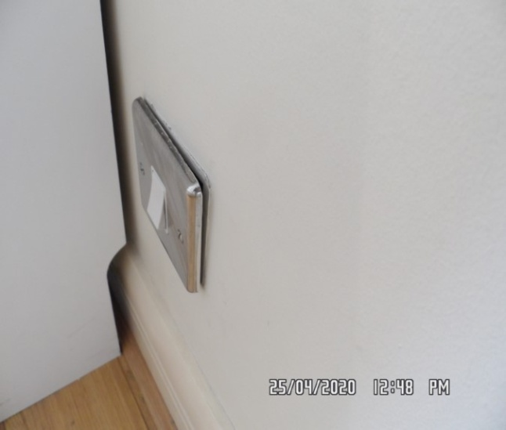**

Bedroom Bedroom

**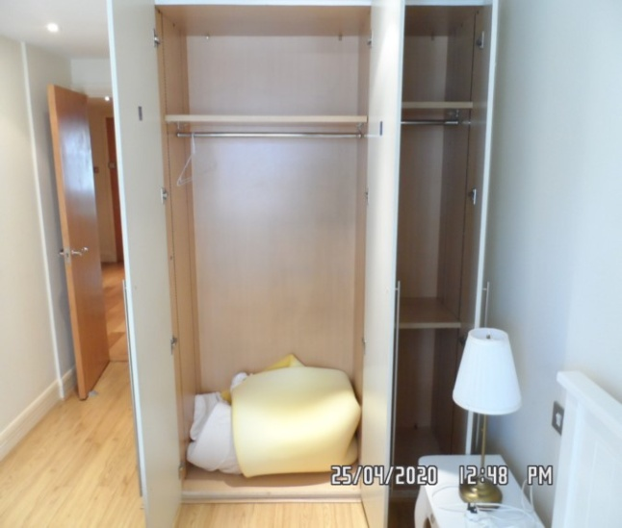 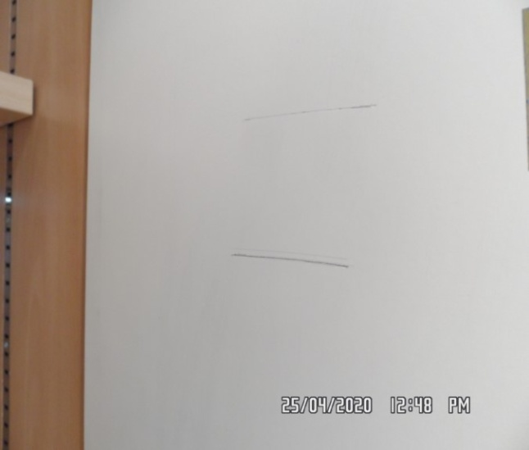**

**RECEPTION**

|  |  |  |  |
| --- | --- | --- | --- |
| **Door** | Exterior Door Frame  Frame painted magnolia  Light wooden varnished threshold upon entrance | 1. 1 or 2 x light chips seen at an angle most notably left-hand side mid to low-level 2. Threshold general marks consistent with use |  |
|  | Exterior Door  Door light wooden varnished | 1. 1 or 2 x chips seen to bottom edges at an angle 2. Some light scuffing seen mid to low-level 3. 1 or 2 x chips seen to top edges at an angle |  |
|  | Interior Door Frame  Frame painted magnolia | 1. 1 or 2 x light scuff marks in places |  |
|  | Interior Door  Door light wooden varnished | 1. 1 or 2 x chips seen to bottom edges at an angle |  |

**RECEPTION**

|  |  |  |  |
| --- | --- | --- | --- |
| **Walls** | Painted magnolia | 1. Not inspected behind any furniture 2. Where visible in places some light scuffing seen mid to low-level 3. Left-hand side wall above radiator cover multiple drill holes with fill applied and patchy paintwork in this area 4. Right-hand side wall at high-level 2 x nail holes seen 5. Rear facing wall 1 x nail hole seen 6. Scattered scuffing and rub marks mid to low-level most notably left and rear facing wall 7. Left and right-hand side of window area some light mould discolouration seen to sealant of windows 8. Facing wall – 4 x residue blu-tack |  |

**RECEPTION**

|  |  |  |  |
| --- | --- | --- | --- |
| **Ceiling** | Painted white | 1. 1 or 2 x scuffs and rub marks seen to ceiling 2. 1 or 2 x chips around recessed spotlight with some scorch marks 3. Intact and good order |  |
| **Lights** | 6 x recessed spotlights with white metal surround | 1. ~~All tested and working for power~~ 1 x not working |  |
| **Woodwork** | Skirting painted white | 1. Where visible ~~1 or 2 x~~ light scuff marks seen 2. Not inspected behind any furniture |  |
| **Switches and sockets** | Silver and white plastic | 1. All appears to be intact and good order |  |

**RECEPTION**

|  |  |  |  |
| --- | --- | --- | --- |
| **Windows** | White metal encasement and frame double-glazed  Section 1:  1 x opening unit to high-level  1 x fixed panel beneath  Section 2:  Double opening door balcony unit  Silver aluminium lever handle with matching surround to both interior and exterior  Integrated Yale lock with 1 x key to interior  Section 3:  Single opening unit to high-level  1 x fixed panel beneath  1 x window key attached to balcony door key with 1 x further star key for balcony door  2 x trickle vents above balcony door opening unit | 1. Glazing all clean to interior, lightly soiled to exterior |  |
| **Curtains** | Brushed stainless steel curtain pole  Brown curtains with light brown lining | 1. General marks consistent with use to pole 2. Pole slightly come loose, maintenance required 3. Some light grey shading in places of curtains |  |

**RECEPTION**

|  |  |  |  |
| --- | --- | --- | --- |
| **Flooring** | Light wooden laminate | 1. Vacuum for the ~~start~~ end of tenancy 2. General scratching and drag marks seen to top surface 3. Forward of balcony door some water staining seen to varnish 4. Not inspected underneath any furniture |  |
| **Radiator** | 2 x radiator covers  White wooden laminate covers with white lattice to front | 1. Radiators not inspected due to covers 2. Left-hand side unit appears to be sloping to centre of shelf, maintenance required |  |
| **Rugs** | 2 x shaggy pile light grey rugs | 1. Both showing light marks consistent with use |  |

**RECEPTION**

|  |  |  |  |
| --- | --- | --- | --- |
| **Sofa** | 1 x Ikea 2-seater white fabric sofa | 1. FFR label not seen 2. Some staining seen to rear cushion in multiple areas 3. Light marks consistent with use in places |  |
| **Coffee table** | White wooden laminate coffee table | 1. 1 or 2 x chips seen to top surface. Possibly 2 more chips 2. Some light scratches in places |  |
| **Dining table** | 1 x glass top dining table with dark wooden laminate legs | 1. 1 or 2 x light marks consistent with use to legs 2. 1 x chip seen at an angle to laminate above left-hand side leg 3. Light scratching to top surface in places |  |

**RECEPTION**

|  |  |  |  |
| --- | --- | --- | --- |
| **Chairs** | 4 x white leather chairs with stainless steel legs | 1. Some light scuffing and shading in places |  |
| **Armchairs** | 2 x dark wooden varnished with white fabric seater cushions | 1. Staining seen to seater cushions 2. Light marks consistent with use to frames |  |
| **Scatter cushions** | 2 x yellow scatter cushions  2 x grey scatter cushions  2 x yellow, white and grey scatter cushions  1 x further floral print in matching colour | 1. All showing light marks consistent with use |  |
| **Throws** | 2 x brown and white throws | 1. Light marks consistent with use |  |

**RECEPTION**

|  |  |  |  |
| --- | --- | --- | --- |
| **Floor lamps** | 2 x white paper shades | 1. Both intact 2. Not tested |  |
| **Table lamp** | 1 x silver base and stem  White shade | 1. Not tested for power |  |
| **TV** | 1 x wall mounted Sharp TV | 1. ~~No remote seen~~ Tenant purchased remote |  |
| **Router** | 1 x Sky wireless router with associated cables | 1. Not tested |  |

Reception Reception

**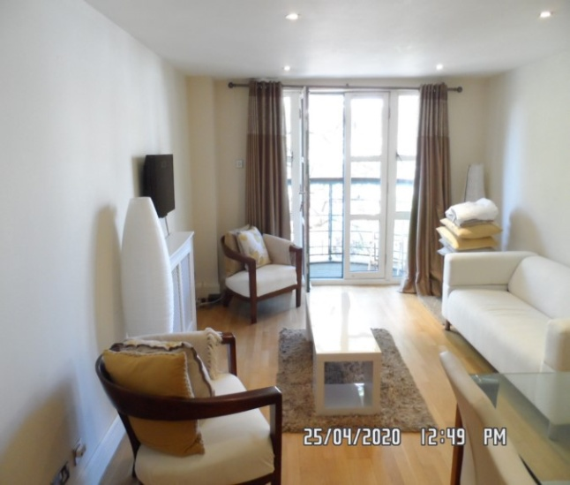 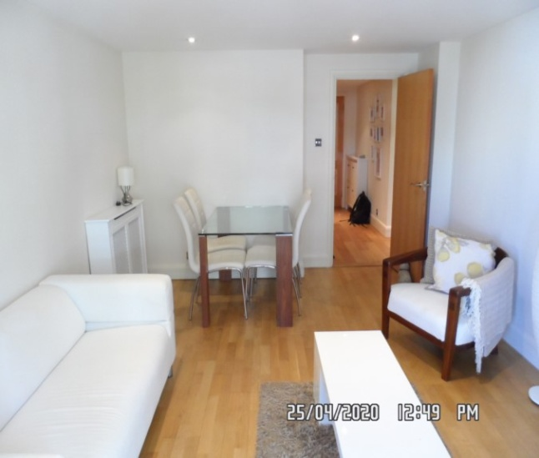**

Reception Reception

**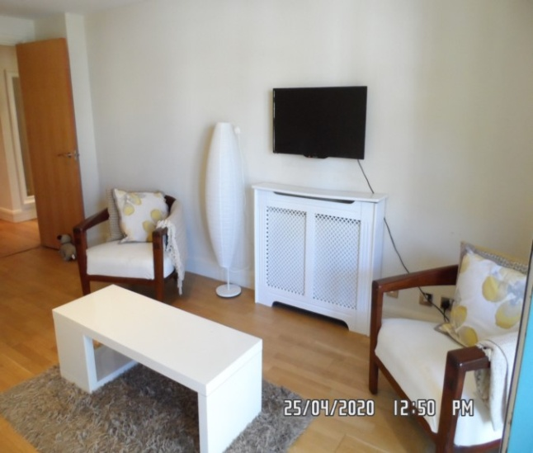 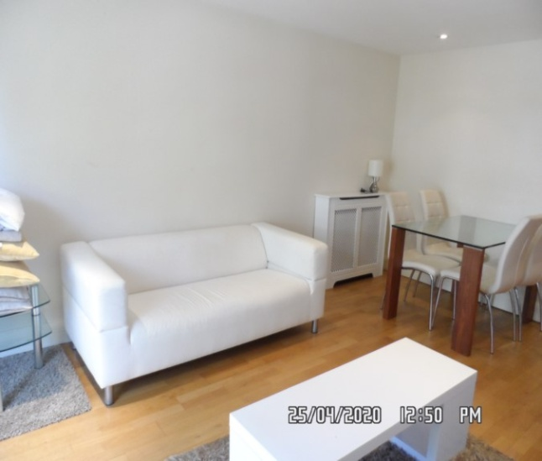**

Reception Reception

**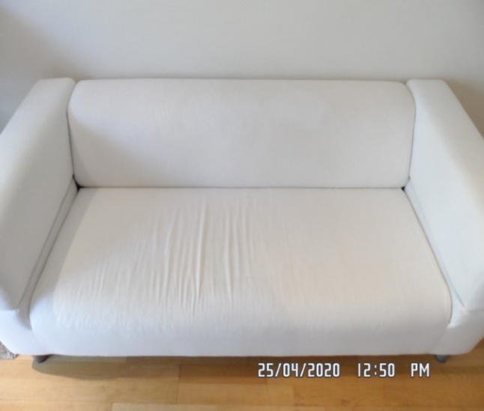 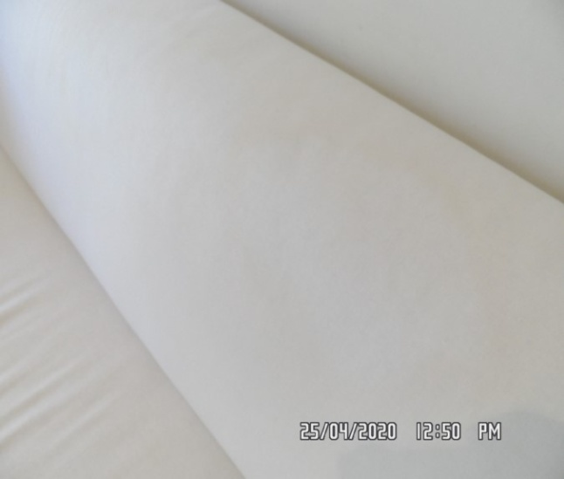**

Reception Reception

**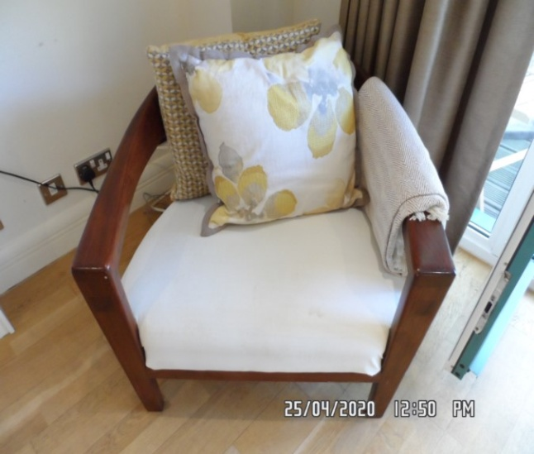 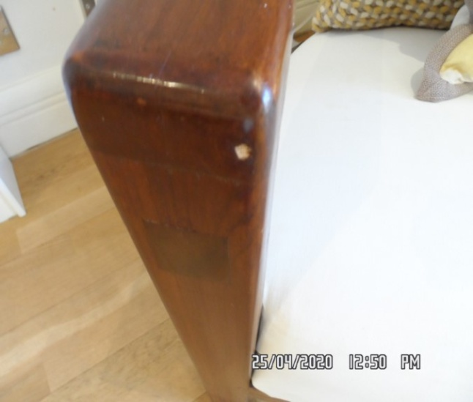**

Reception Reception

**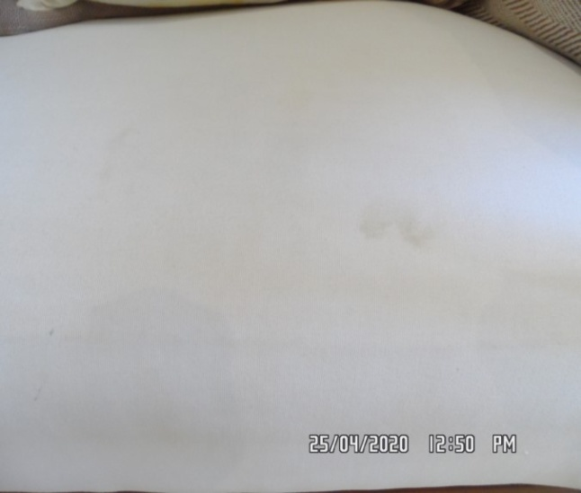 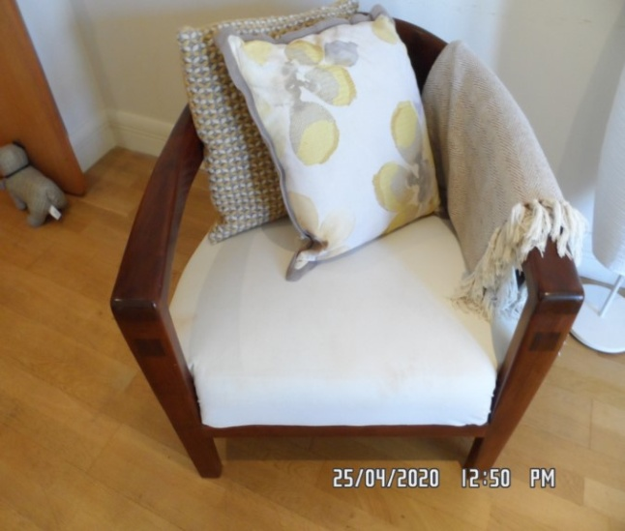**

Reception Reception

**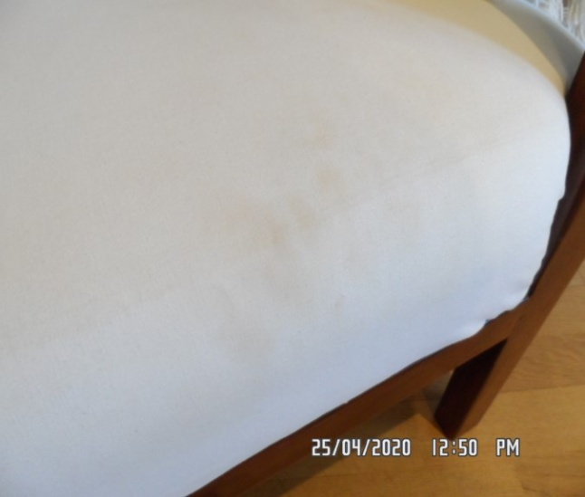 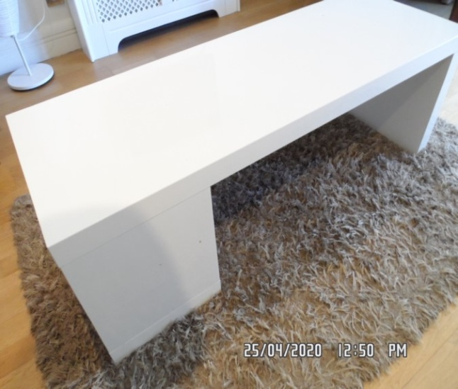**

Reception Reception

**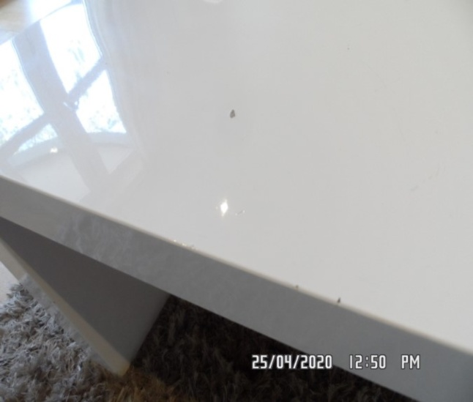 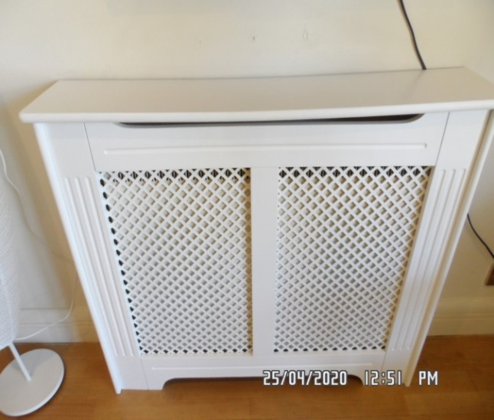**

Reception Reception

**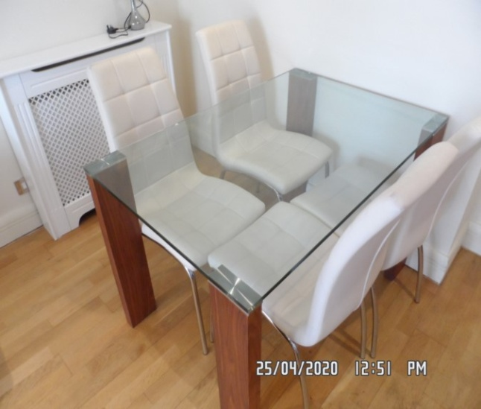 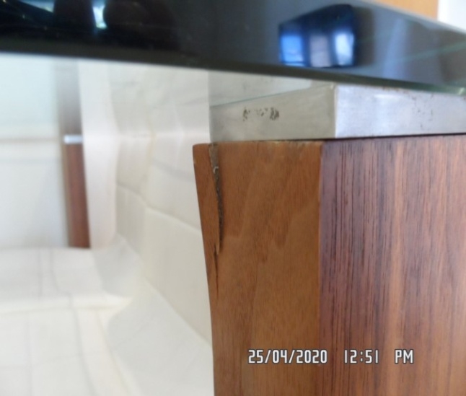**

Reception Reception

**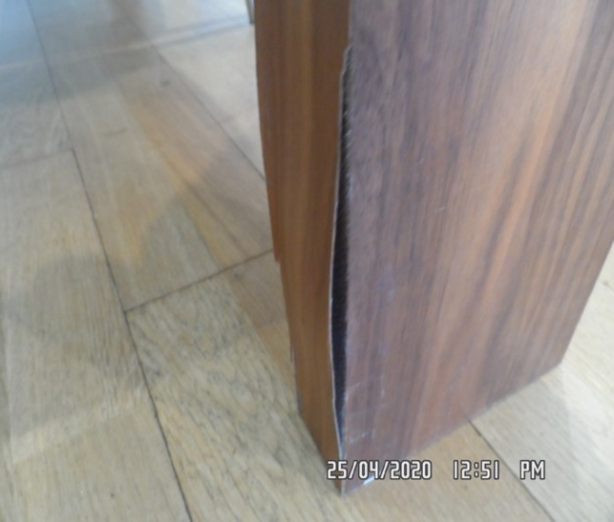 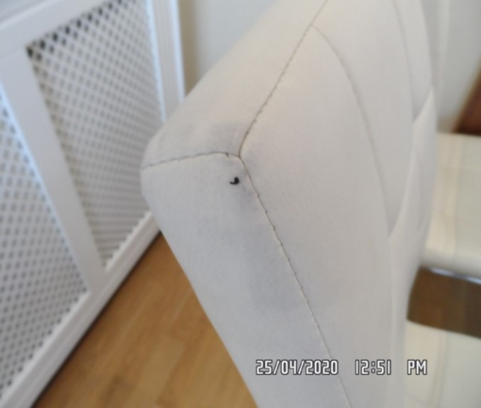**

Reception Reception

**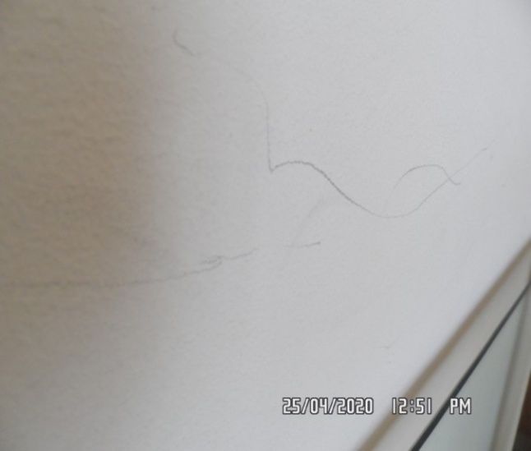 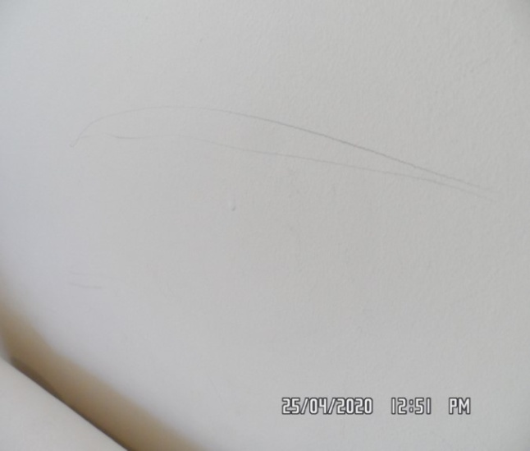**

Reception Reception

**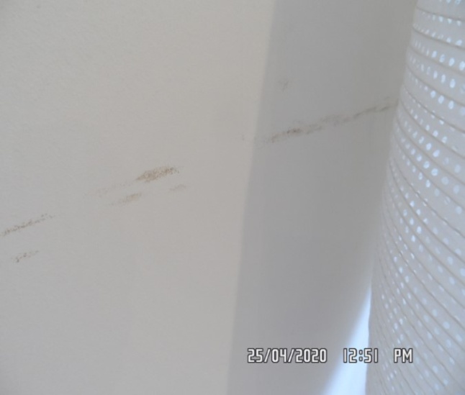 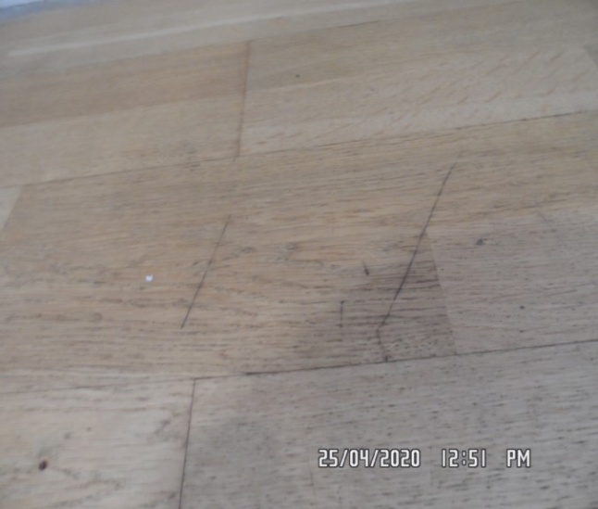**

Reception Reception

**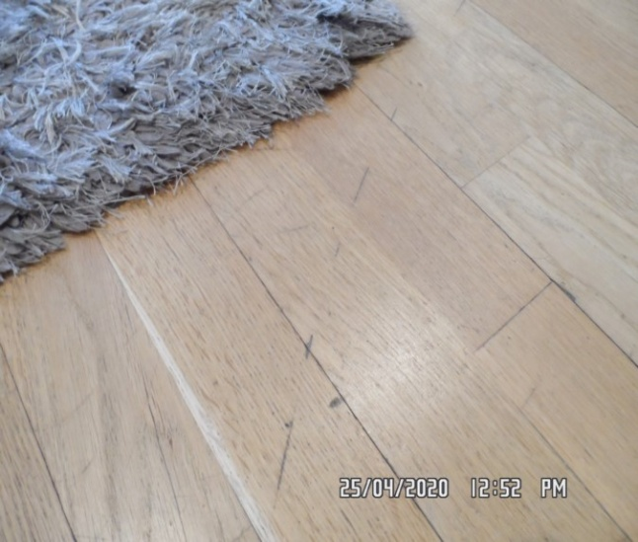 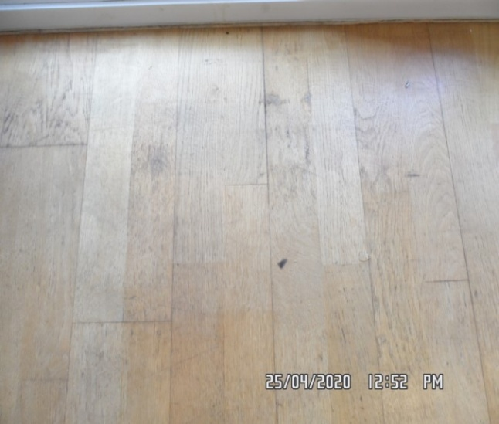**

Reception Reception

**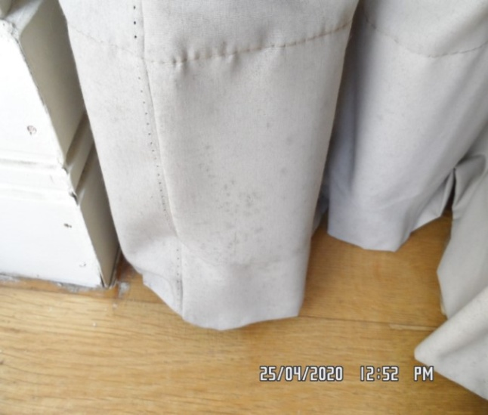 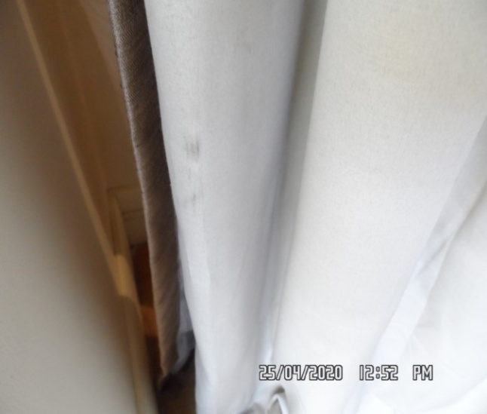**

Reception Reception

**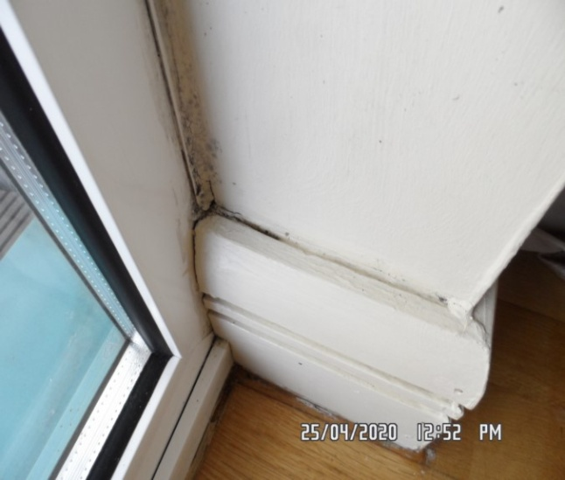 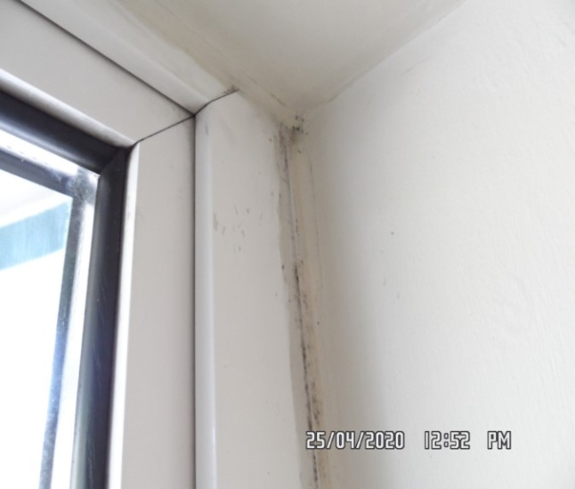**

Reception Reception

**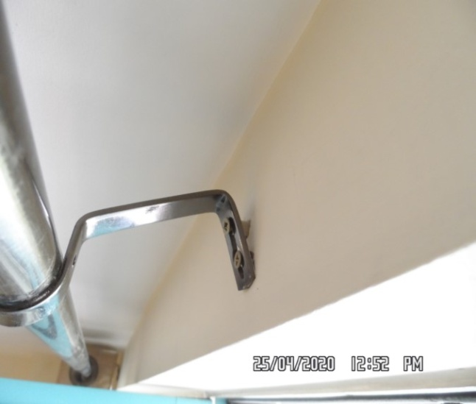 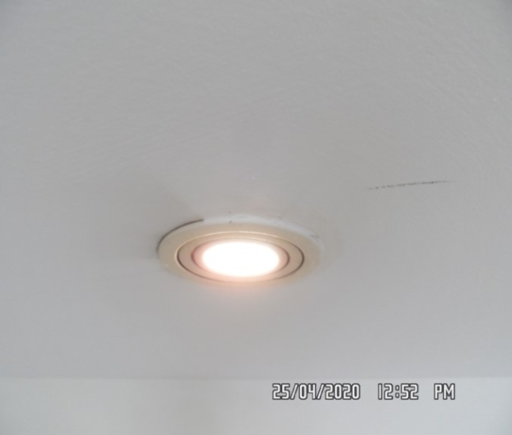**

**BALCONY**

|  |  |  |  |
| --- | --- | --- | --- |
| **Flooring** | Wooden decking | 1. Some green moss build up seen 2. Some tarnishing seen to varnish |  |
| **Railing** | Part green and silver metal  Dark wooden varnished rail | 1. General weathering seen 2. General tarnishing seen to varnish |  |
| **Chairs** | 2 x light wooden varnished hold up chairs | 1. Both showing general marks consistent with use |  |

Balcony Balcony

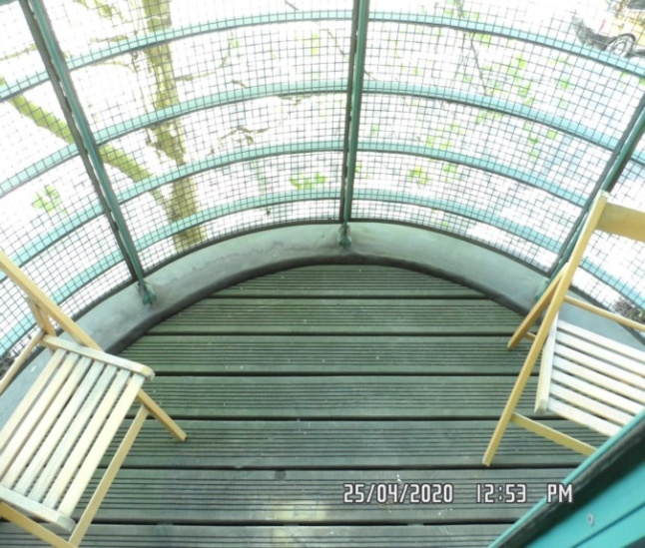 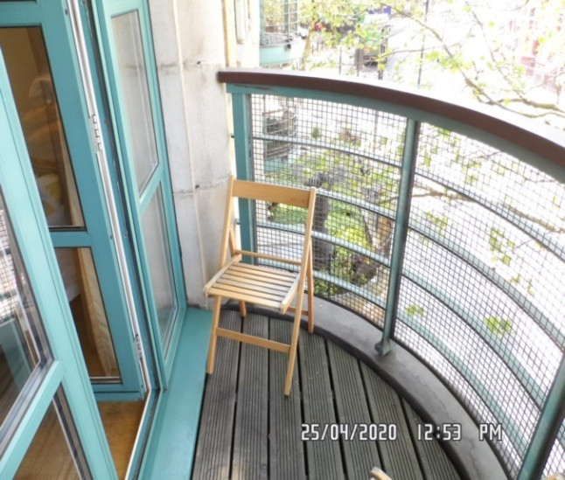

Balcony Balcony

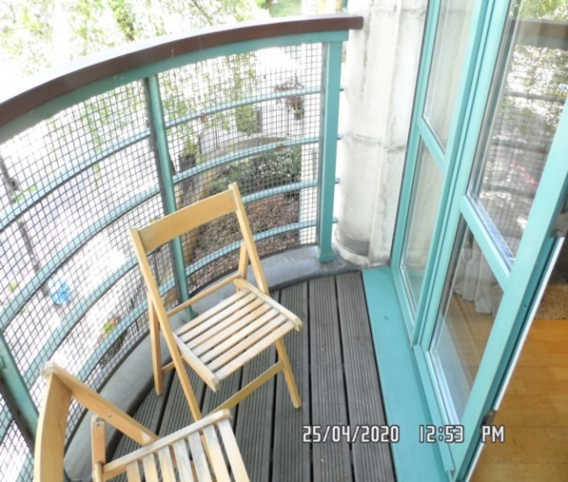 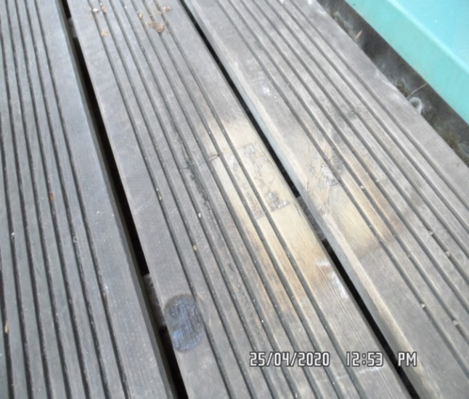

Balcony Balcony

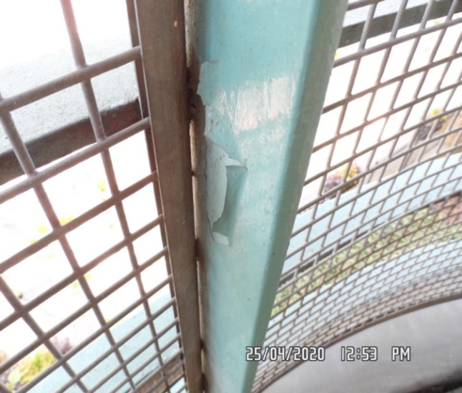 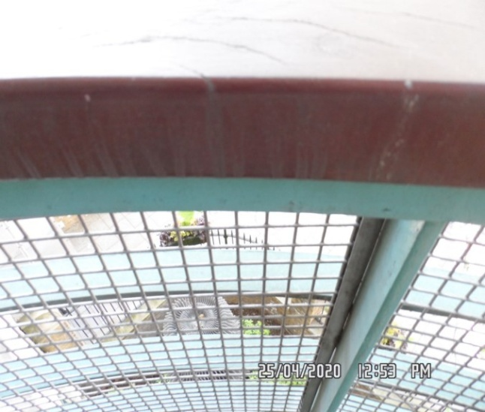

**KITCHEN**

|  |  |  |  |
| --- | --- | --- | --- |
| **Door** | Exterior Door Frame  Frame painted magnolia  Light wooden varnished threshold upon entrance | 1. 1 or 2 x light scuffs seen mid to low-level 2. Threshold general marks consistent with use |  |
|  | Exterior Door  Door light wooden laminate  Stainless steel lever handle with matching surround | 1. 1 or 2 x chips seen to bottom edge at an angle |  |
|  | Interior Door Frame  Frame painted magnolia | 1. 1 or 2 x light scuffs and chips seen at an angle mid to low-level |  |
|  | Interior Door  Door light wooden laminate  Stainless steel lever handle with matching surround  1 x fire chain attached to door | 1. Some chipping seen to bottom edge at an angle |  |

**KITCHEN**

|  |  |  |  |
| --- | --- | --- | --- |
| **Walls** | Painted magnolia | 1. Above stand up some light drip marks seen and light scuffing most notably to right-hand side wall multiple splash marks seen 2. Back walls – near door way paint bubbles low level 3. Right hand side – 1 x brass picture hook upper level 4. Back wall – 2 x chrome hook |  |
| **Ceiling** | Painted white | 1. Ceiling above sink some splash marks seen 2. 1 or 2 x chips seen around recessed lights in places most notably above cooker hood area 3. 1 or 2 x light scuff marks elsewhere above kitchen units |  |
| **Lights** | 4 x recessed spotlights with white metal surround  4 x under unit lights with brushed stainless steel surround | 1. ~~All tested for power~~ 1 x not working 2. Under unit lights not tested |  |
| **Woodwork** | Skirting painted magnolia | 1. Cracking seen to top surface with some light scuffing in places |  |

**KITCHEN**

|  |  |  |  |
| --- | --- | --- | --- |
| **Switches and sockets** | Silver and white plastic | 1. All appears to be intact and good order |  |
| **Flooring** | Grey and white speckled tile with grey grout | 1. ~~Scattered debris in places~~ 2. ~~Further cleaning required~~ 3. Discolouration seen to grout 4. 1 or 2 x tiles appears to be slightly uneven |  |
| **Radiator** | 1 x white metal Dimplex heater attached to skirting | 1. Not tested for power |  |
| **Unit Description - Units are inspected from left to right** | Light wooden laminate to both interior and exterior  Brushed stainless steel handles | 1. Kitchen units clean to both interior and exterior ~~in places~~ 2. Exterior doors tarnishing seen to varnish |  |

**KITCHEN**

|  |  |  |  |
| --- | --- | --- | --- |
| **Wall unit 1** | Single opening unit  2 x shelves and 1 x base shelf |  |  |
| **Wall unit 2** | Bi-folding door unit  2 x shelves and 1 x base shelf | 1. Hinges slightly loose |  |
| **Wall unit 3** | Single opening unit  2 x shelves and 1 x base shelf  Assortment of contents to interior | 1. Exterior door scratching seen from door handle to wall unit 2 2. ~~Unable to fully inspect interior~~   2. Now located in unit 5 and 6 |  |
| **Wall unit 4** | Single flap opening unit  1 x base shelf | 1. Hinge to right-hand side slightly at an angle |  |
| **Wall unit 5** | Single opening unit  2 x shelves and 1 x base shelf | P.S unit 5 and 6 double door unit |  |

**KITCHEN**

|  |  |  |  |
| --- | --- | --- | --- |
| **Wall unit 6** | Single opening unit  2 x shelves and 1 x base shelf |  |  |
| **Floor units (inspected from left to right)** |  |  |  |
| **Floor unit 1** | Single opening unit  1 x shelf and 1 x base shelf |  |  |
| **Floor unit 2** | Single opening unit containing boiler |  |  |
| **Floor unit 3** | Bank of 3 x drawers |  |  |
| **Floor unit 4** | Single opening unit underneath sink  1 x base shelf  Cut-out for associated pipe work and cable work to rear wall |  |  |

**KITCHEN**

|  |  |  |  |
| --- | --- | --- | --- |
| **Kickboard** | Silver wooden laminate kickboard | 1. Underneath oven and boiler section at an angle with some duct tape in places 2. Further maintenance required |  |
| **Work surface** | White and grey speckled worktop and stand-up | 1. Clean to top surface 2. 1 or 2 x chips seen to front edge at an angle 3. 1 or 2 x light scratches elsewhere |  |
| **Sink** | Brushed stainless steel unit with matching drainer section  1 x half size bowl and 1 x full size bowl  Stainless steel integrated mixer tap  1 x drainer plug seen | 1. Clean to interior      1. Water residue |  |

**KITCHEN**

|  |  |  |  |
| --- | --- | --- | --- |
| **Extractor** | 1 x Bosch extractor fan  2 x filters and 2 x lights | 1. ~~All tested and working for power~~ 1 x light not working 2. Some light ingrained staining seen to filters in places 3. Serial number and model not seen |  |
| **Hob** | Black induction unit  Brushed stainless steel trim  4 x plates  4 x black knob controls | 1. Heavy burnt on residue seen to bottom 2 x plates, although tested for power. Additional carbon residue to 2 other plates |  |
| **Oven** | Zanussi oven  Model: ZOB35471XK  Serial number: 91328440  Brushed stainless steel, black and clear viewing glass  2 x silver knob controls  1 x LED display  3 x black buttons attached  2 x stainless steel racks  1 x grey grill pan with stainless steel rack to interior | 1. Appears to be in good clean order 2. 1 x sticker seen to exterior 3. Tested for power 4. Clean to interior |  |

**KITCHEN**

|  |  |  |  |
| --- | --- | --- | --- |
| **Fridge/ freezer** | Bosch fridge/ freezer  Serial number: KIV32V01GB/02  Mode: KGKIVV34A    4 x white plastic shelves  3 x glass shelves with white plastic guards  1 x salad crisper drawer  1 x light and light cover  Freezer with 4 x clear plastic drawers | 1. Light grey shading seen to rear interior wall 2. Tested for power 3. Light not currently showing power to fridge 4. ~~Grey shading seen to rear wall~~ already mentioned above 5. 1 x glass shelf guard has hairline crack to front edge 6. Freezer heavy ~~scratching~~ cracking seen to front panel 7. Chipping to handle 8. Some rusting to interior shelves in places (see picture for description) 9. Second freezer drawer crack to front |  |
| **Washing machine** | 1 x Miele washer/ dryer  Serial number: 41/85852013  Model: HT2670  1 x light to interior of sealant | 1. Soap tray powder residue to interior 2. 1 x large hairline crack to door (see photo) – now secured with black duct tape 3. Sealant to interior discolouration seen 4. Further cleaning required 5. Currently showing power |  |

**KITCHEN**

|  |  |  |  |
| --- | --- | --- | --- |
| **Microwave** | 1 x Bosch microwave  Serial number: HMT8555GB/01  Type: X60291026  Brushed stainless steel with mirror glass to exterior  1 x glass turn table  1 x light to interior | 1. Tested for power 2. Clean to interior |  |
| **Boiler** | 1 x Classic boiler | 1. Not tested |  |
| **Doorstop** | 1 x brushed stainless steel doorstop with black rubber tip mounted to flooring | 1. Intact ~~and good order .~~ Slight stain |  |
| **Contents** | Assortment of utensils, crockery and cutlery see- unsure whether this is previous tenant or landlord (see picture for description) | 1. Still present – see photo |  |

Kitchen Kitchen

**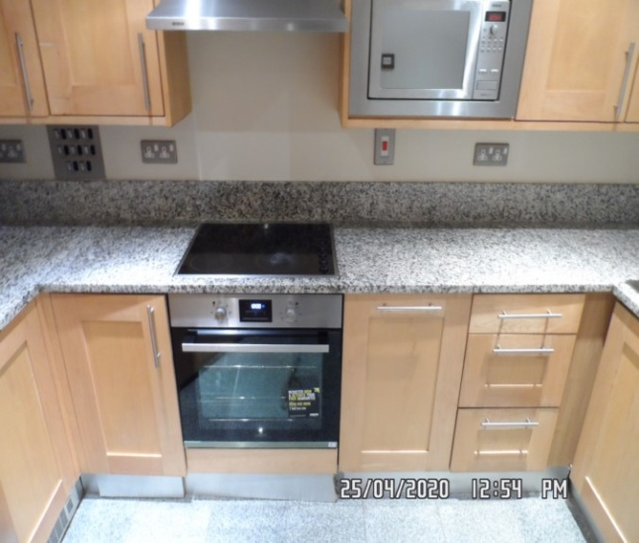 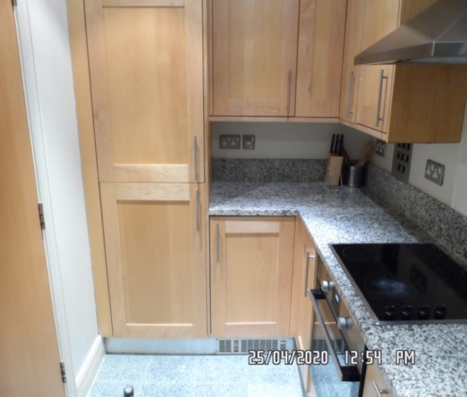**

Kitchen Sink

**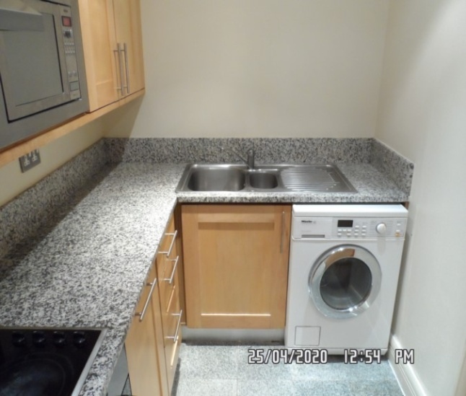 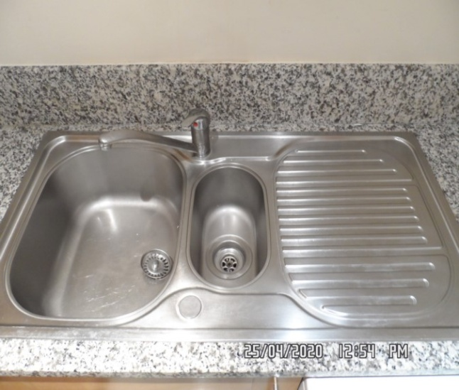**

Kitchen Kitchen

**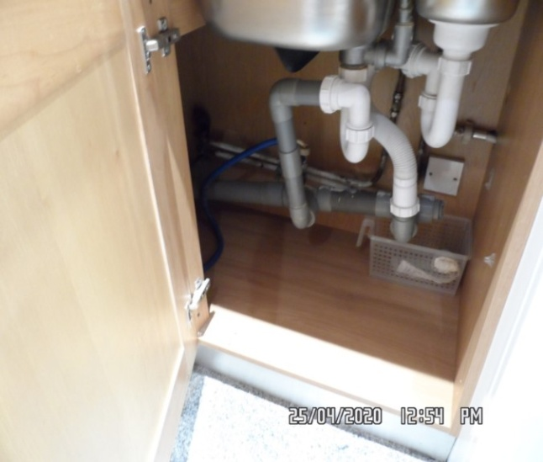 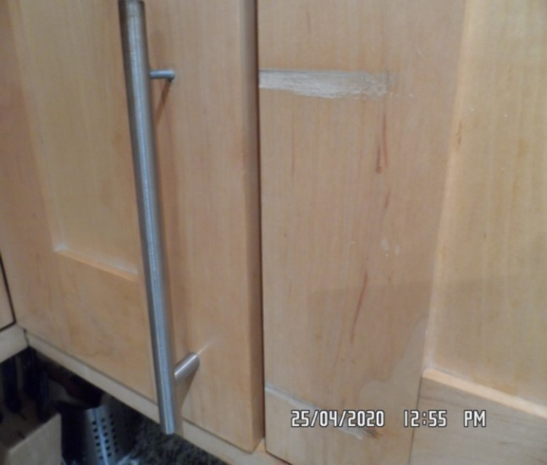**

Fridge/ freezer Fridge/ freezer

**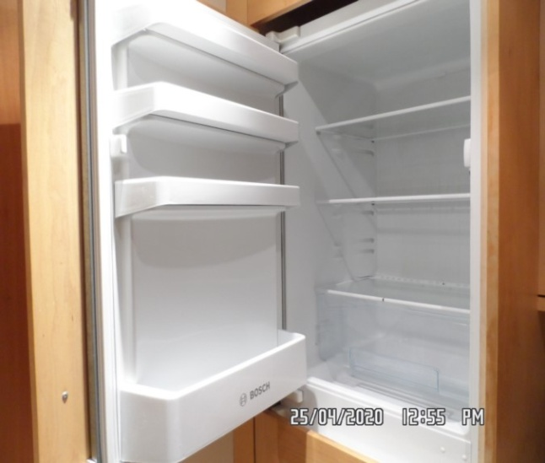 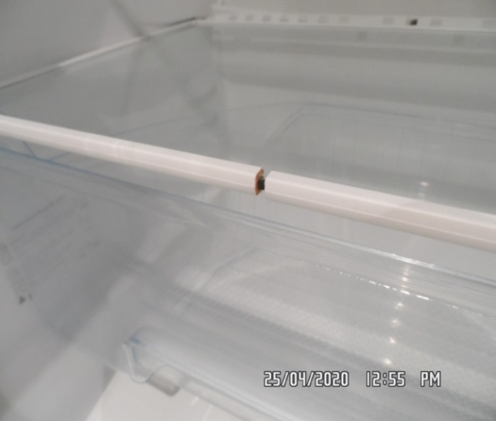**

Fridge/ freezer Fridge/ freezer

**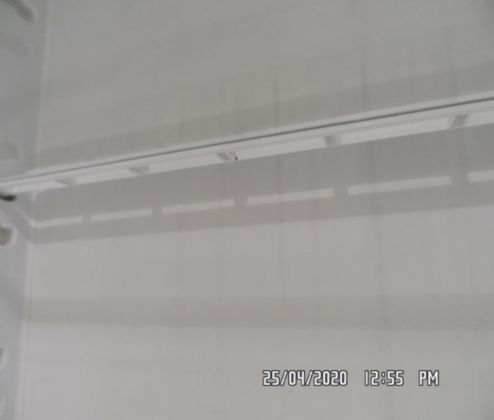 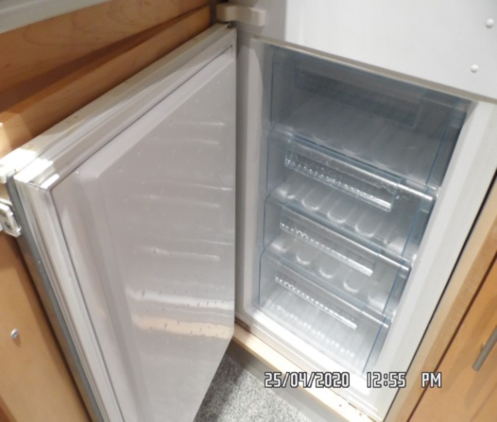**

Fridge/ freezer Fridge/ freezer

**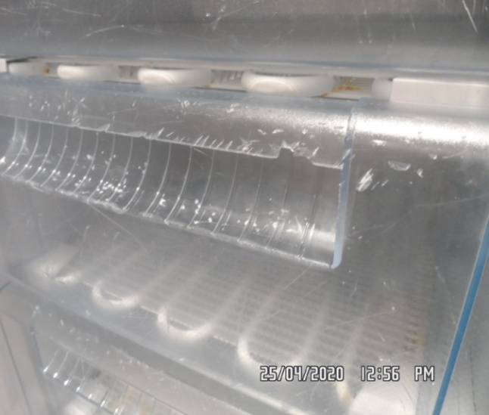 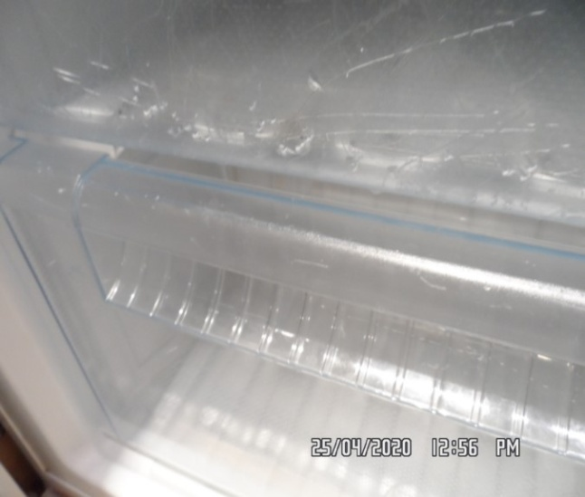**

Fridge/ freezer Extractor

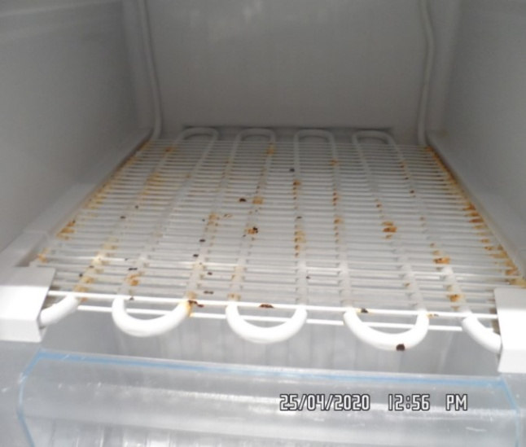 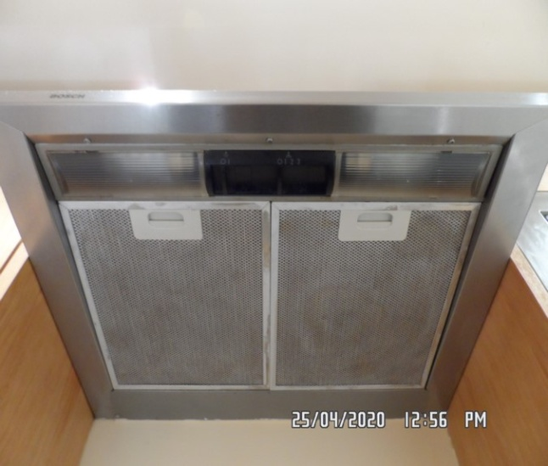

Extractor Hob

**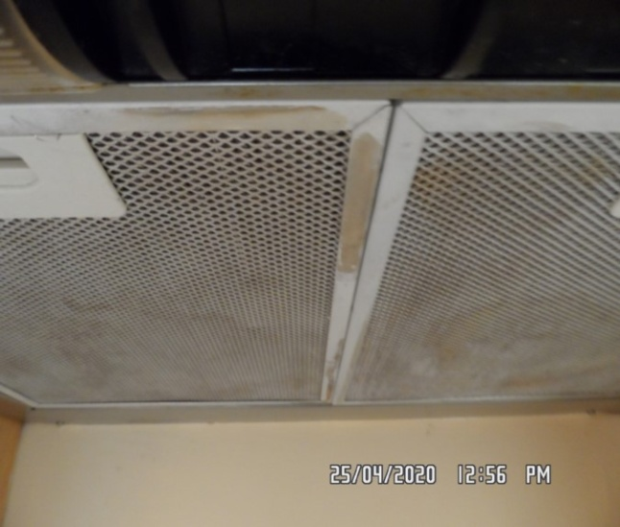 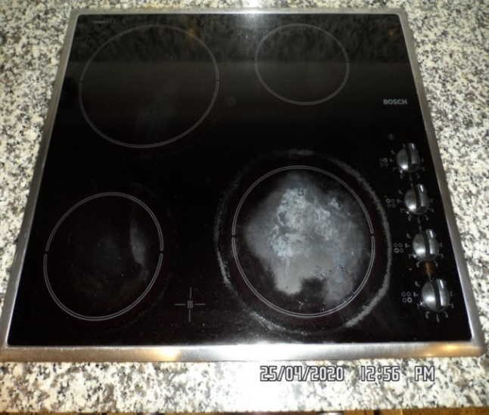**

Oven Dishwasher

**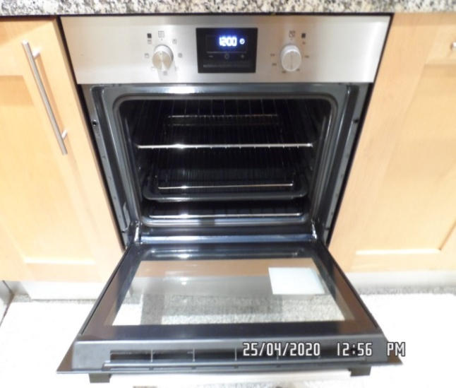 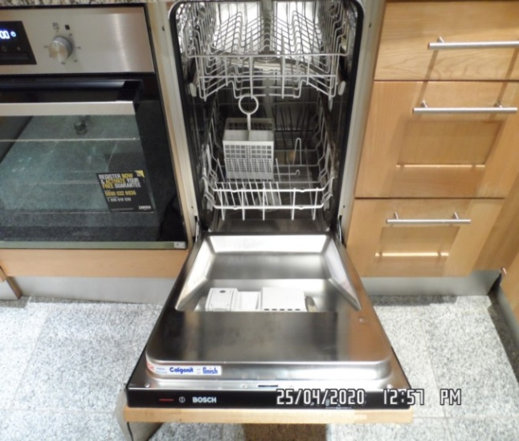**

Washing machine Washing machine

**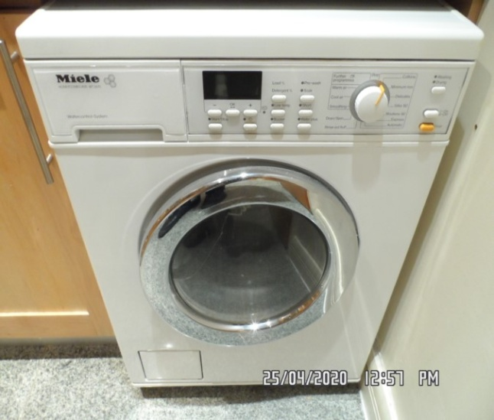 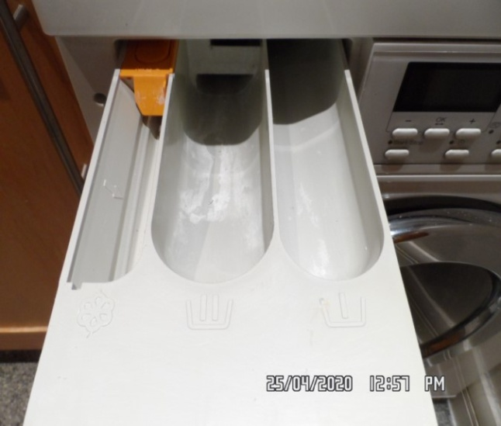**

Washing machine Washing machine

**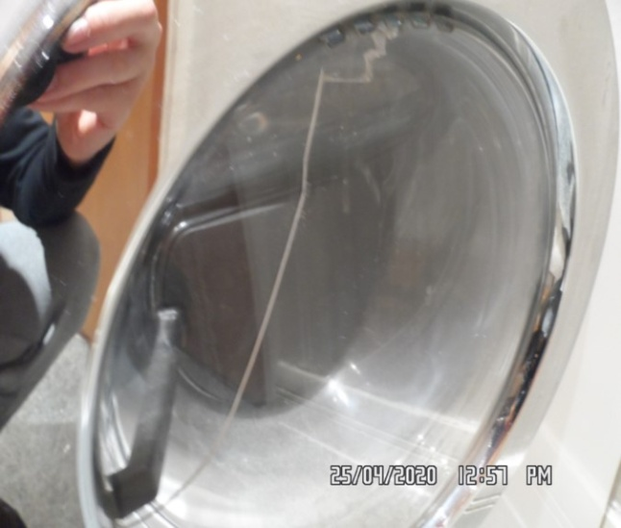 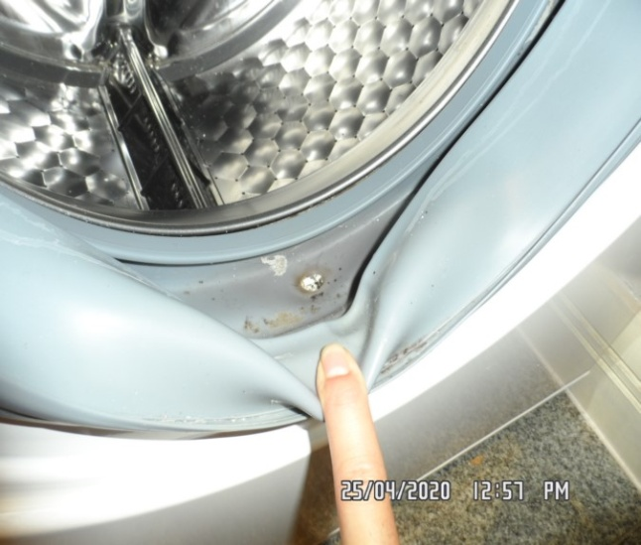**

Kitchen Kitchen

**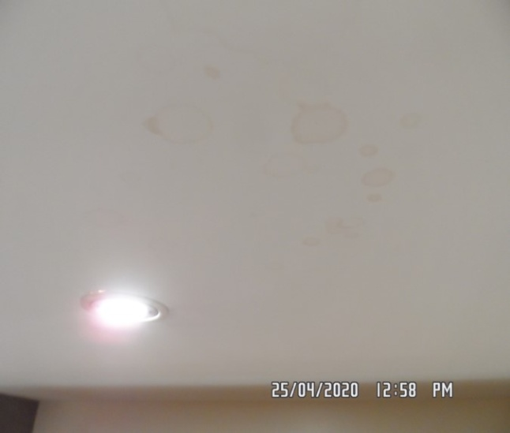 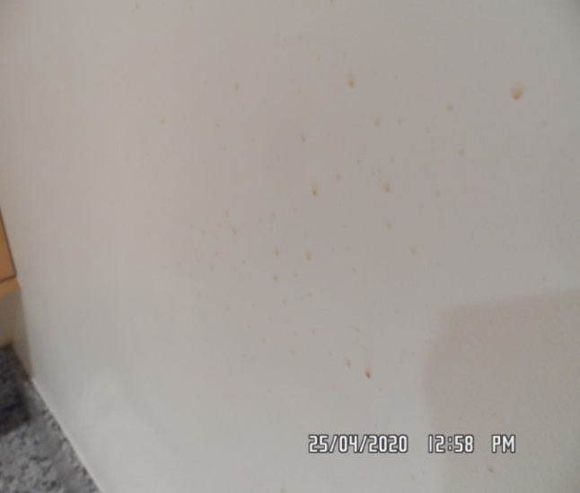**

Kitchen Kitchen

**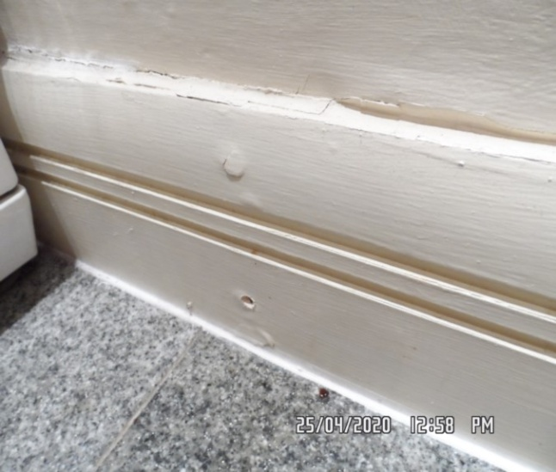 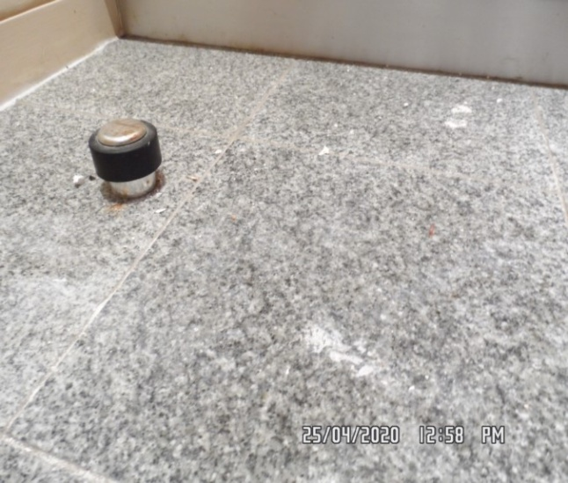**

Kitchen Kitchen

**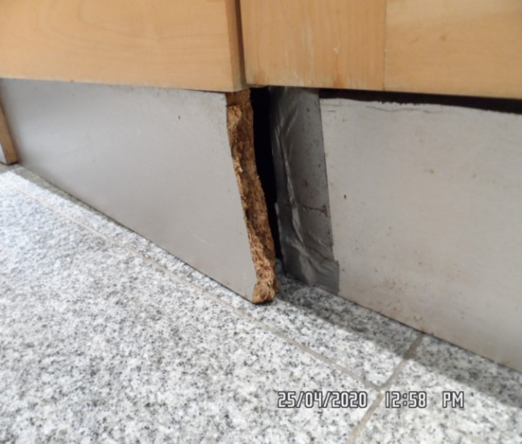 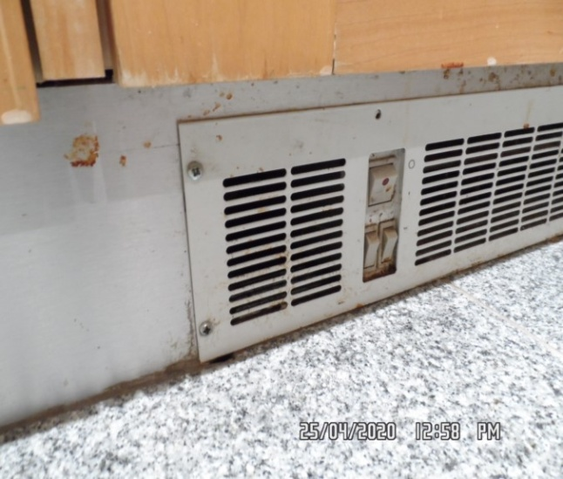**

**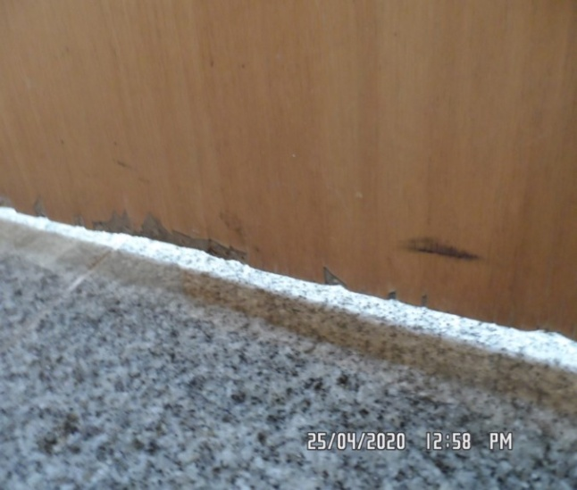**

Kitchen Kitchen

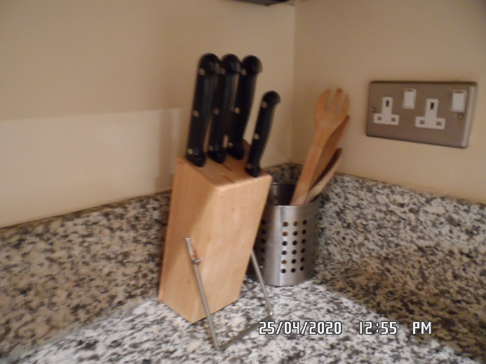 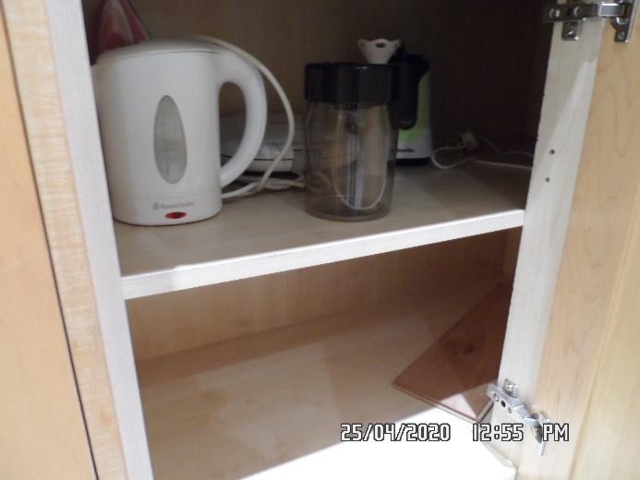

Kitchen Kitchen

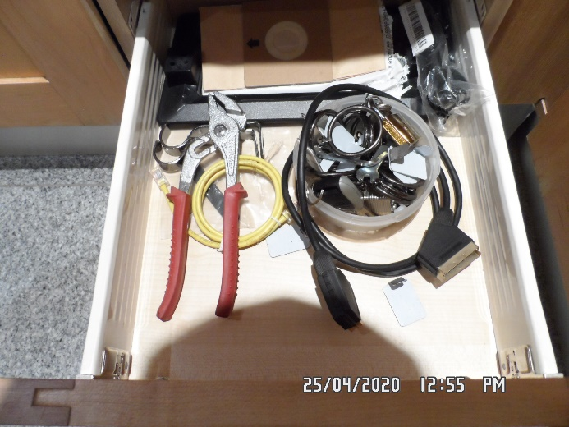 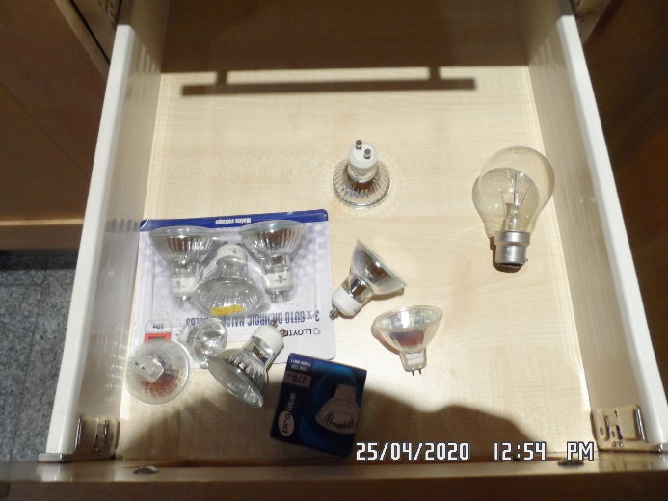

Kitchen Kitchen

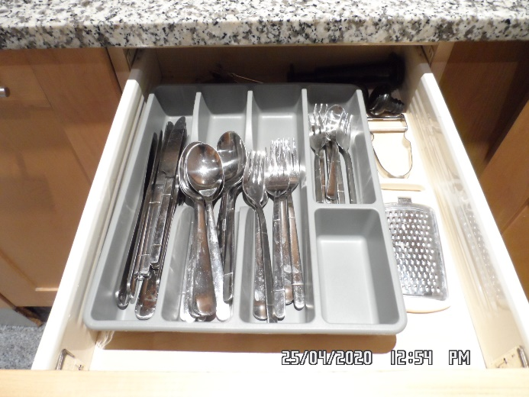 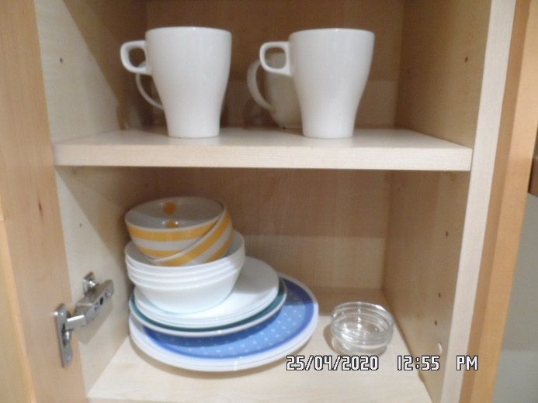

Kitchen

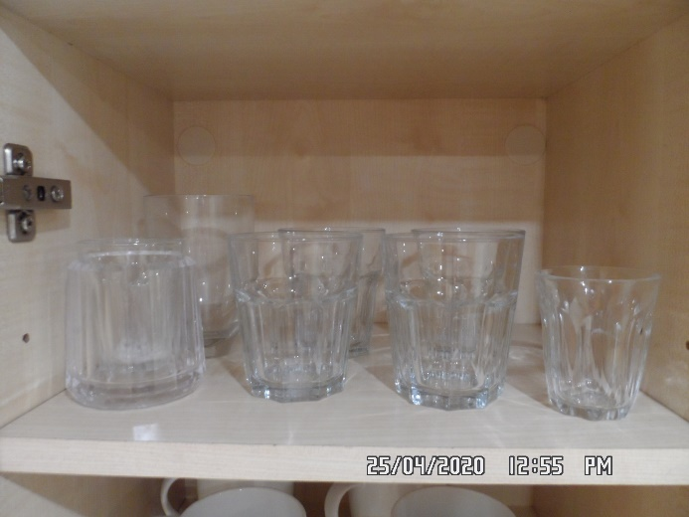

# DECLARATION AT CHECK IN

This inventory has been examined and, subject to marginal comments found to be correct.

## On behalf of the landlord

on behalf of the tenant \_\_\_\_\_

commencement of tenancy **\_\_\_\_\_\_**

## **N.B**

This inventory is correct to the best of our knowledge but advise you to examine its contents prior to signing, as we can not be held responsible for any errors or omissions. Descriptions are for identification purposes only.

The relevant utility companies must check all meter readings, as we can not be held responsible for any discrepancies

**Please ensure that all items listed in this inventory are in the same location at the end of the tenancy.**

**ADDITIONAL AMENDMENTS**

|  |  |  |
| --- | --- | --- |
| DATE | DESCRIPTION OF CHANGES | AGENTS/LANDLORD SIGNATURE |
|  |  |  |
|  |  |  |
|  |  |  |
|  |  |  |
|  |  |  |
|  |  |  |
|  |  |  |
|  |  |  |
|  |  |  |

WHEN ADDITIONS/AMENDMENTS ARE MADE BY THE LANDLORD, TENANT OR AGENT THE RELATIVE PARTIES MUST BE INFORMED

**GENERAL COMMENT**

It should be noted that it is not the responsibility of the Inventory Clerk to open, unpack, empty or itemise items stored in carrier bags

or other containers  unless it is made specifically clear they are the property of the Landlord.

|  |
| --- |
| **CHECK IN REPORT OF CONDITION AT: DATE:25/04/2020** |

|  |  |
| --- | --- |
| **PROPERTY ADDRESS:** | FLAT 16,  199 OLD MARYLEBONE ROAD,  LONDON,  NW1 |
| **CLIENT:** | FIRST PORT |
| **CONTACT:** | Denise |

|  |  |  |
| --- | --- | --- |
| **ELECTRIC** | **GAS** | **WATER** |
| **METER NUMBER:**  **UNABLE TO ACCESS CUPBOARD AS CONCIERGE NOT PRESENT\*\*\*** | **METER NUMBER:** | **METER NUMBER:** |
| **READING:** | **READING:** | **READING:** |
| **LOCATION:**  **Basement cupboard.** | **LOCATION:**  **-** | **LOCATION:**  **-** |

|  |  |  |  |  |  |  |
| --- | --- | --- | --- | --- | --- | --- |
| **PROPERTY DESCRIPTION** | | | | | | |
| **ROOM** | **QTY** | **ROOM** | | **QTY** | **EXTERIOR AREAS** | **QTY** |
| RECEPTION | 1 | BATHROOMS | | 1 | FRONT GARDEN |  |
| OFFICE |  | WC | |  | REAR GARDEN |  |
| BEDROOMS | 1 | UTILITY | |  | SWIMMING POOL |  |
| DRESSING ROOM |  | STORE ROOM | | 1 | GARAGE |  |
| STAIRCASE & LANDINGS |  | CELLAR | |  | ANNEX |  |
|  |  |  | |  | BALCONY | 1 |
| □ HOUSE □ FLAT | | | □ UNFURNISHED □ FURNISHED | | | |

|  |
| --- |
| **GENERAL SUMMARY** |

|  |  |  |
| --- | --- | --- |
| **GENERAL CONDITION** | □ Professionally cleaned for start of tenancy :-  □ Domestically cleaned for the start of tenancy :-  □ Further general cleaning required:-  □ A full professional clean is required :- | **FURTHER COMMENTS** |
| **ODOUR** | □ Pet □ Smoking □ Cooking  □ Musty | □ N/a |
| **DECORATIVE ORDER / WOODWORK** | □ Advised freshly painted  □ Good Order  □ Defects as noted  □ Dusty  □ Woodwork scuffed/chipped |  |
| **FLOORING** | □ Professionally cleaned for start of tenancy  □ Good Order □ Defects as noted  □ Vacuumed for start of tenancy  □ Requires further cleaning □ New |  |
| **CURTAINS / BLINDS** | □ Professionally cleaned for start of tenancy  □ Vacuumed in situ for start of tenancy  □ Requires further cleaning  □ Defects as noted □ Good Order | □ N/A |
| **BLIND REGULATIONS** | □ Chain break connector in place  □ Chain Tidy in place  □ Regulations not met | □ N/A |
| **UPHOLSTERY** | □ Professionally cleaned for start of tenancy  □ Vacuumed in situ for start of tenancy  □ Good Order  □ New □ Defects as noted | □ N/A |
| **FFR LABELS** | □ FFR Labels Seen □ FFR Labels Not seen |  |
| **LINEN** | □ New □ In use □ None provided  □ Domestically cleaned □ Freshly laundered | □ Requires further cleaning |
| **LIGHTS** | □ All working order  □ Bulbs missing / not working |  |
| **KITCHEN / APPLIANCES** | □ All clean order  □ All Appliances power tested  □ Fridge left open power off □ Freezer left open power off  □ Fridge left shut power on □ Freezer left shut power on | □ Requires further cleaning |
| **BATHROOMS/**  **WC** | □ Clean □ All fitments free of lime scale  □ Water outlets tested and working | □ Mildew to areas as noted  □ Requires further cleaning |
| **WINDOWS** | □ Fitments complete  □ Clean to interior □ Clean to exterior | □ Requires further cleaning |
| **GARDEN /**  **TERRACE/**  **BALCONY** | □ Seasonal order | □ N/A  □Further attention required |

|  |
| --- |
| **FIRE SAFTY** |

|  |  |
| --- | --- |
| **SMOKE ALARM** | □ Mains powered □ Battery powered  □ Power light on □ Unable to test  □ Tested with Canned smoke and working order    **□ Smoke alarm not working – Agent/client advised** ……………………… |
| **CARBON MONOXIDE ALARM** | □ Tested and working order □ Light seen □ N/a |

|  |
| --- |
| **POSITION OF** |

|  |  |
| --- | --- |
| **STOP COCK** | Store room. |
| **FUSE BOARD** | Store room. |
| **ALARM PANEL** | None. |

|  |
| --- |
| **MANUALS PROVIDED** |
| □ None provided □ Within report on page ……… |

|  |
| --- |
| **NOTES** |
|  |

|  |  |  |  |
| --- | --- | --- | --- |
| **KEYS** | | | |
| **KEY TYPE** | **SERIAL NUMBER** | | **QTY** |
| Yale (Silver) |  | | ×5 |
| Fob (Blue) |  | | ×1 |
| Mailbox |  | | ×1 |
| Mul-t-lock |  | | ×2 |
|  |  | |  |
|  |  | |  |
|  |  | |  |
|  |  | |  |
| **KEYS RECEIVED BY:**  □ AGENT □ TENANT □ LANDLORD □ CONCIERGE □ BUILDER  □ Management keys used □ None provided  \*Tick as applicable | | | |
| **NAME PRINTED:**  **Fletcher stucky**  **……………………………………………………..** | | **SIGNATURE :**  **…………………………………………………….** | |

\*N.B – Heavy items will not be moved or inspected behind/under, for health & safety reasons. We will not be held liable should any damages/stains/marks be found during the tenancy in these areas. Should the occupant find any of the above they should, inform the landlord/agent immediately and if/where possible take photographic evidence and pass to the relevant parties.

|  |  |  |
| --- | --- | --- |
| **CLIENT CALLED AT** | | |
| **TIME:** | **VOICE MESSAGE LEFT FOR:** | **SPOKEN WITH:** |

|  |  |  |
| --- | --- | --- |
| **IN ATTENDANCE AT CHECK IN** | | |
| **INDEPENDENT INVENTORY CLERK** | **NAME PRINTED**  Gary Krienkie  ……………………………………………… | **SIGNATURE**    ……………………………………..………….. |

|  |
| --- |
| **In attendance:**  □ LANDLORD □ TENANT □ INVENTORY CO. □ RELOCATION REP |

|  |  |
| --- | --- |
| **NAME PRINTED**  ………………………………..……………… | **SIGNATURE**  ………………………………..……………….. |

|  |
| --- |
| **CHECK OUT REPORT OF CONDITION AT: DATE:** 24/10/2020 |

|  |  |
| --- | --- |
| **PROPERTY ADDRESS:** | Flat 16  199 Old Marylebone Rd  NW1 5QR |
| **CLIENT:** | First Port Lettings Services |
| **CONTACT:** | Denise Shaw |

|  |  |  |
| --- | --- | --- |
| **ELECTRIC** | **GAS** | **WATER** |
| **METER NUMBER:**  DO9A07747 | **METER NUMBER:**  Bot applicable | **METER NUMBER:**  Unknown |
| **READING:** | **READING:**  Not applicable | **READING:**  Unknown |
| **LOCATION:**  Basement cupboard | **LOCATION:**  Not applicable | **LOCATION:**  Unknown |
| **SUPPLIER:** | **SUPPLIER:**  Not applicable | **SUPPLIER:** |

|  |  |  |  |  |  |  |
| --- | --- | --- | --- | --- | --- | --- |
| **PROPERTY DESCRIPTION** | | | | | | |
| **ROOM** | **QTY** | **ROOM** | | **QTY** | **EXTERIOR AREAS** | **QTY** |
| RECEPTION | 1 | BATHROOMS | | 1 | FRONT GARDEN | 0 |
| OFFICE | 0 | WC | | 0 | REAR GARDEN | 0 |
| BEDROOMS | 1 | UTILITY | | 0 | SWIMMING POOL | 0 |
| DRESSING ROOM | 0 | STORE ROOM | | 1 | GARAGE | 0 |
| STAIRCASE & LANDINGS | 0 | CELLAR | | 0 | ANNEX | 0 |
| STUDY | 0 | BALCONY | |  |  |  |
| KITCHEN | 1 |  | |  |  |  |
| □ HOUSE □ FLAT | | | □ UNFURNISHED □ FURNISHED | | | |

|  |
| --- |
| **GENERAL SUMMARY** |

|  |  |  |  |
| --- | --- | --- | --- |
| **GENERAL CONDITION** | □ Professionally cleaned for end of tenancy :-  □ Domestically cleaned for the end of tenancy :-  □ Further general cleaning required:-  □ A full professional clean is required :-  □ Cleaning company present :- | **FURTHER COMMENTS**  □ Tenants items left in property  □ Rubbish to be removed | |
| **ODOUR** | □ Pet □ Smoking □ Cooking | □ N/a | |
| **DECORATIVE ORDER/**  **WOODWORK** | □ Advised freshly painted  □ Defects as noted □ Dusty  □ Woodwork scuffed/chipped |  | |
| **FLOORING** | □ Professionally cleaned for end of tenancy  □ Vacuumed for end of tenancy |  | |
| **CURTAINS / BLINDS** | □ Professionally cleaned for end of tenancy  □ Vacuumed in situ for end of tenancy |  | |
| **UPHOLSTERY** | □ Professionally cleaned for end of tenancy  □ Vacuumed in situ for end of tenancy  □ Defects as noted | □ N/A |
| **LINEN** | □ In use □ None provided  □ Freshly laundered | □ Requires further cleaning |
| **LIGHTS** | □ All working order  □ Bulbs missing / not working |  |
| **KITCHEN / APPLIANCES** | □ All clean order  □ All appliances power tested  □ Fridge left open power off □ Freezer left open power off  □ Fridge left shut power on □ Freezer left shut power on | □ Requires further cleaning |
| **BATHROOMS/**  **WC** | □ Clean □ All fitments free of lime scale  □ Water outlets tested and working | □ Mildew to areas as noted  □ Requires further cleaning |
| **WINDOWS** | □ Fitments complete  □ Clean to interior / exterior | □ Requires further cleaning |
| **GARDEN /**  **TERRACE** | □ Seasonal order | □ N/A  □Further attention required |
| **TELEPHONE** | □ Handset Provided □ None provided |  |

|  |  |
| --- | --- |
| **CLEANING RECEIPT SUPPLIED** | □ None provided |

|  |  |
| --- | --- |
| **Company name**  **& Amount** |  |

|  |
| --- |
| **MISSING MANUALS** |
|  |

\*N.B – Heavy items will not be moved or inspected behind/under, for health & safety reasons. We will not be held liable should any damages/stains/marks be found during the tenancy in these areas. Should the occupant find any of the above they should, inform the landlord/agent immediately and if/where possible take photographic evidence and pass to the relevant parties.

|  |  |
| --- | --- |
| **TENANTS FORWARDING DETAILS** | |
| **NAME:**  **ADDRESS:**  **TEL:**  **EMAIL:** |  |

|  |  |  |  |
| --- | --- | --- | --- |
| **KEYS** | | | |
| **KEY TYPE** | **SERIAL NUMBER** | | **QTY** |
| Silver Yale |  | | 6 |
| Blue fob |  | | 2 |
| Mailbox |  | | 1 |
| Multilock |  | | 2 |
|  |  | |  |
| **KEYS RECEIVED BY:**  □ AGENT □ TENANT □ LANDLORD □ CONCIERGE □ BUILDER  □ Management keys used □ None provided  \*Tick as applicable | | | |
| **NAME PRINTED:**  NAIL SALIH  **……………………………………………………..** | | **SIGNATURE :**  **…………………………………………………….** | |

|  |  |  |
| --- | --- | --- |
| **CLIENT CALLED AT** | | |
| **TIME:** | **VOICE MESSAGE LEFT FOR:** | **SPOKEN WITH:** |

|  |  |  |
| --- | --- | --- |
| **IN ATTENDANCE AT CHECK OUT** | | |
| **INDEPENDENT INVENTORY CLERK** | **NAME PRINTED**  ……………………………………………… | **SIGNATURE**  ……………………………………..………….. |

|  |
| --- |
| **In attendance:**  □ LANDLORD □ TENANT □ INVENTORY CO. □ RELOCATION REP |

|  |  |
| --- | --- |
| **NAME PRINTED**  ………………………………..……………… | **SIGNATURE**  ………………………………..……………….. |